Can you write some rhyming lists?

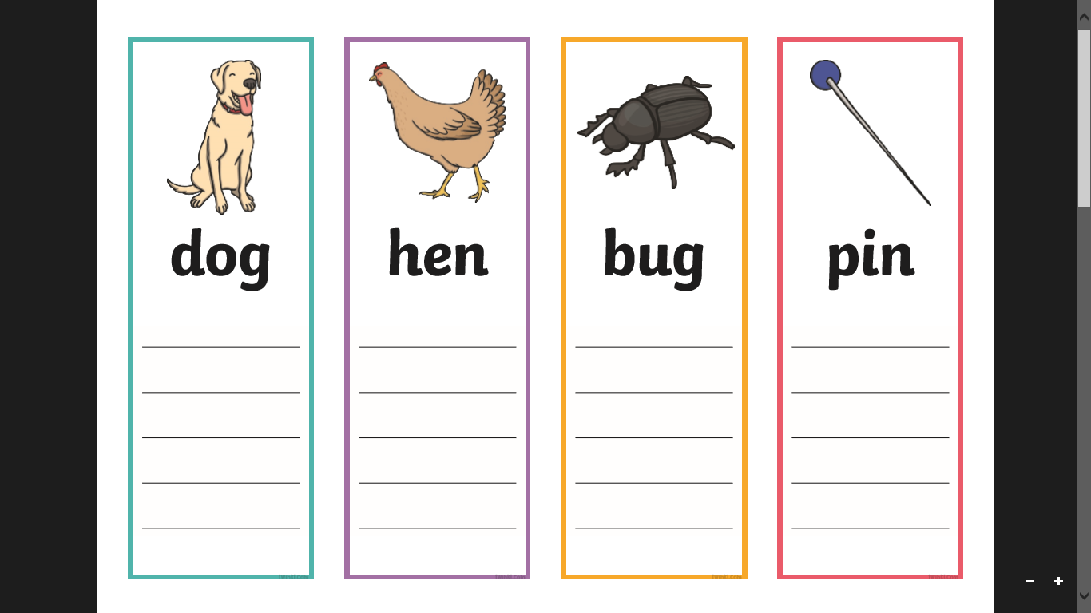

**frog**

**log**