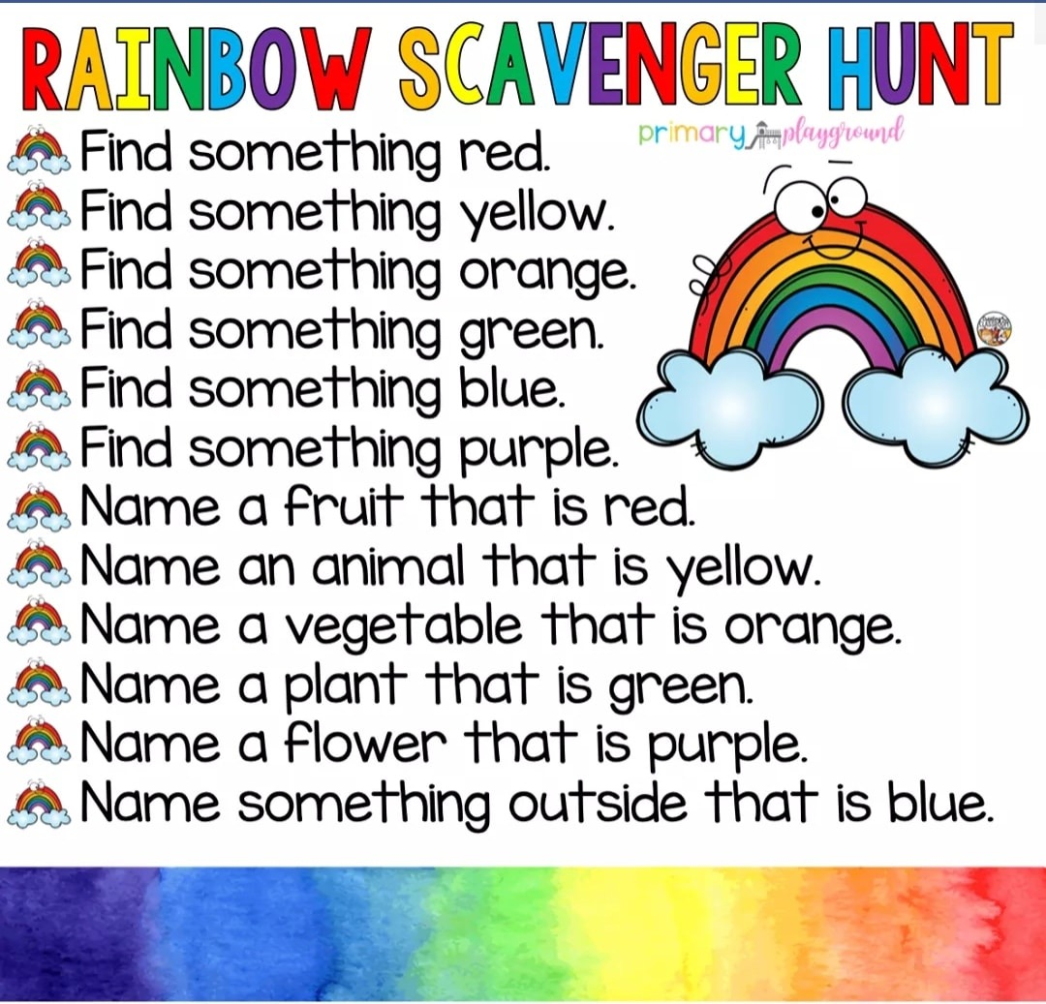
What can you find in your house that are the colours of the rainbow? Can you make a rainbow? We would love to see what you can create! Send them to parentshare@ryhopeinfantschool.org.uk
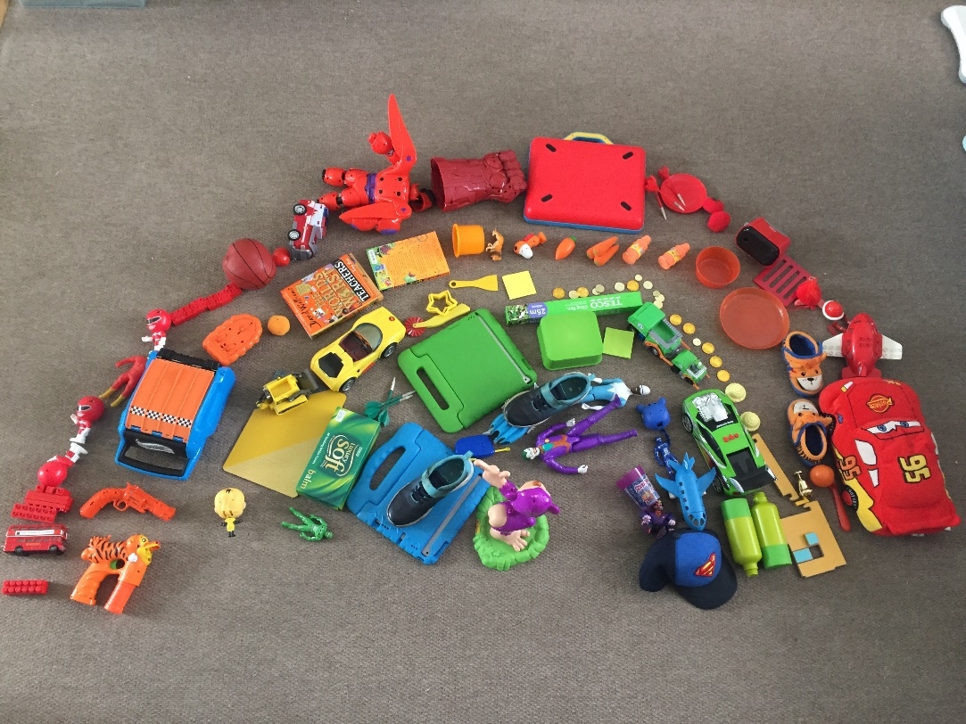
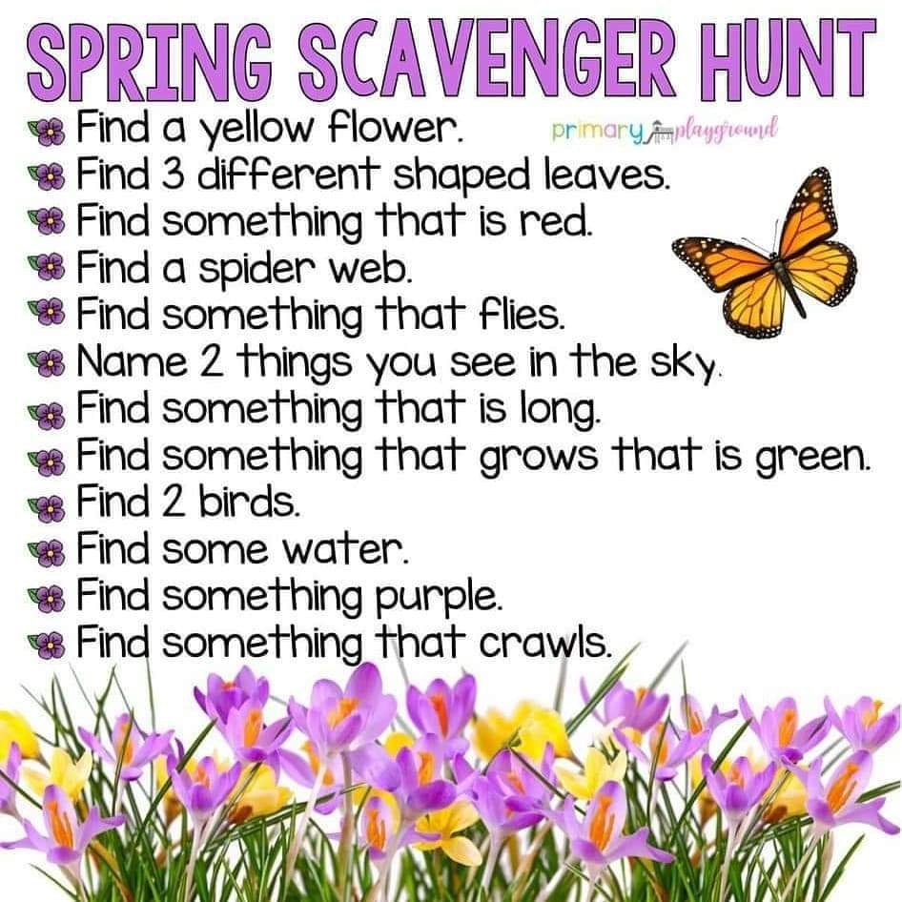

Can you paint/draw a spring picture. We would love to see some photos of your artwork! Send them to parentshare@ryhopeinfantschool.org.uk
