Read the story ‘The Very Hungry Caterpillar.’ Or watch the animated version on YouTube.  https://www.youtube.com/watch?v=75NQK-Sm1YY | Retell the story from memory by using the pictures in the book. Or watch the animated film on YouTube with the sound turned off and practise retelling the story.
Discuss healthy and unhealthy foods from the story.  Make up your own version of the story. Can you think of a healthy food that you would eat each day? What would you eat on Saturday? | Set up a shop with food from your kitchen. Take turns with a family member to be the shopkeeper/customer. Practise counting 1p coins to buy the food. Discuss which foods are healthy and unhealthy.
Make a fruit smoothie. 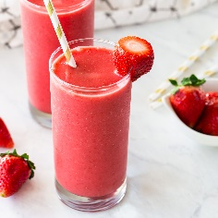 | Count the pieces of fruit on each page.  Have a go at some of the caterpillar counting activities available on our blog.
Discuss the days of the week. What day is it today? It was ___ yesterday so what comes next? Can you remember the days of the week song that we sing at nursery? | Discuss the life cycle of a butterfly.
Use playdough to make a caterpillar.  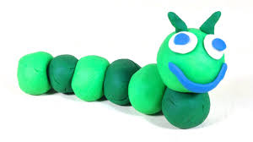 | Make a butterfly picture. Have a look at some of the butterfly craft ideas on our blog. We would love to see your artwork so don’t forget to e-mail us some photographs or send them on Facebook Messenger.  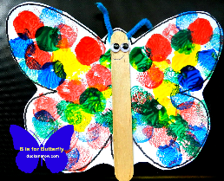
Can you collect some natural materials to make a butterfly picture?  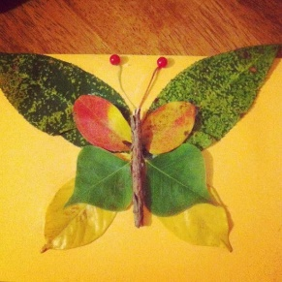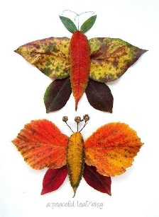 | Make a fruit salad and taste a new fruit that you have never had before. Did you like it? Can you make a fruit salad that looks like a butterfly?  