 | Miss Macleod’s  Group | Miss Clarke’s  Group | Miss Doughney’s Group | Miss Welch’s  Group
Monday | Continue making flashcards for all the sounds you have learned so far! Remember to practise these daily to help you remember your sounds  Recap the sound and spelling ‘ew’.  Write some ‘ew’ words e.g. flew, grew, nephew.  Can you put sound buttons on?  Have a go at writing some ‘ew’ words of your own.  Can you put these words into sentences? Remember capital letters and full stops! | Write each homophone (same sounding word with a different spelling and meaning) on a single piece of paper. These are your own flashcards for this week!! – there, their, they’re, where, wear, here, hear.  Quickwrite (as fast as you can with no spelling mistakes!) – there, their, they’re, where, wear, here, hear.  Can you write a sentence with each word in?  Self-check sentences – punctuation, correct spellings etc. | Pattern hunting - ‘zh’ letter strings  Vision usual treasure  Usually pleasure television  Unusual measure visual  Can you spot any patterns in these words? Group them together, say them aloud and see what you notice. Can you find the rule to help you to remember these spelling?  Can you find any more words that fit into these letter strings? | Introduce words with consonant blends – drip, droop, drown, crept, crash, cramp.  Tear up some pieces of paper and write a different word on each small piece.  Add sound buttons, segment and blend.  Verbally rehearse words using pieces of paper as flashcards.  Play splat!  Spread words on the floor and ask parent to shout out known words at random. Splat correct word!
Tuesday | Recap sound and spelling ‘oe’  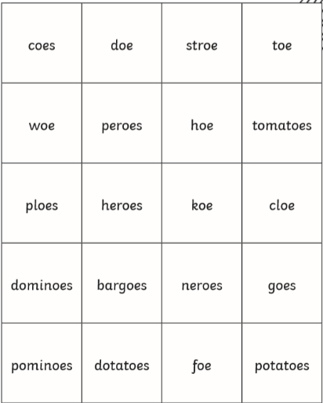  Read the words below and decide if they are real or nonesense!  Choose some of the real ‘oe’ words and try to put them into a sentence. Remember capital letters and full stops! | Use your flashcards from yesterday…  Play splat!!  Spread your flashcards out on the floor and read words at random then splat correct spelling to match - there, their, they’re, where, wear, here, hear.  Can you draw a picture to represent each word to help you remember the correct meaning?  Remember a homophone is:  -A word that sounds the same but has a different spelling and meaning. | G?Pattern hunting – silent letters  Can you spot the silent letters in these words? Write out the words with their sound buttons to help you.  Knot knaw wrong  Wrench knee gnash  Gnarled wrap knife  Example:  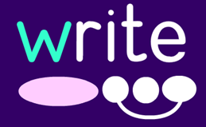  Can you think of any of your own silent letter words? | Recap words learned yesterday - drip, droop, drown, crept, crash, cramp.  Play look, cover, write check.  - Look at the word and identify sounds.  - Cover the word fully.  - Write the word.  - Check your spelling, If incorrect change to the correct spelling and try again.
Wednesday | Recap sound and spelling ‘au’.  Write the words launch, August, haunted can you put sound buttons on?  Read through the letter – see how many au words you can spot!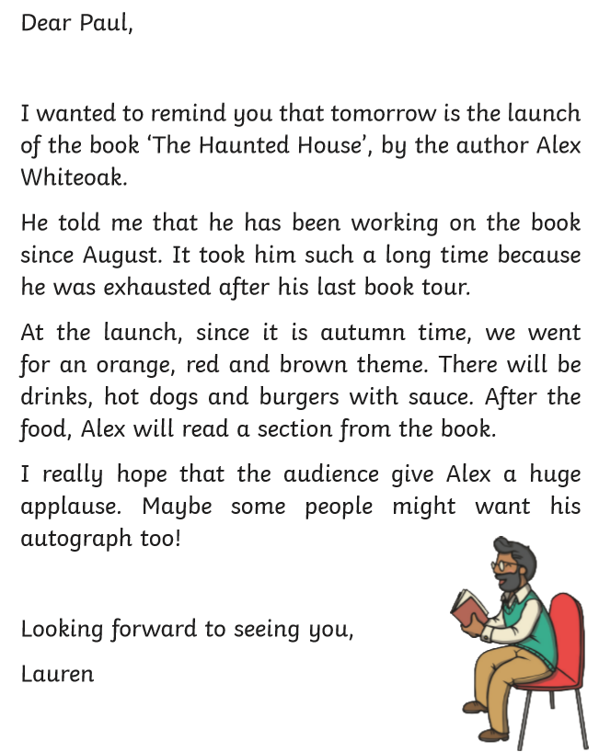 | Recap the alternative sound for ‘y’ – making the ‘ie’ sound.  Countdown (write all words within 1 minute) – fly, sky, by, my, reply, sly, try.  Separate piece of paper into 6 sections and choose 6 words from count down list. Ask your parent to be a bingo caller and read out known alternative ‘y’ words at random then mark off the spelling to match the word!  Write sentence and self-check – I try to fly in the sky. | How many different graphemes can you remember for the ‘ee’ sound?  ee, ea, e-e, y, e, ey, eo, ie, ei  Create a table with columns and see how many words you can think of for each grapheme.  Which 2 graphemes are usually found at the end of words? (y, ey)  How many words do you know what end in y or ey? Can you find a way to remember which words end in y and which end in ey? | Introduce words with consonant blends – brim, brown, bloom, blue, frown, fresh, frost, float.  Read, segment and blend.  Quickwrite (as fast as you can with no spelling mistakes!) – brown, bloom, blue, frown, fresh, frost, float.  Can you write a sentence with each word in?  Remember a capital letter, finger spaces and a full stop. Check your sentence – Does it have everything we have mentioned? If not, correct it.
Thursday | Keep practising reading some of our tricky words!  Oh, their, people, little, were, so, do, like, looked, called, asked, said, have, one, though, who, again, come, some, there.  Can you write these words into sentences?  (Bingo: If you have a grown up to play with you have a go at tricky word bingo! Pick 6 of our tricky words and ask your grown up to be the bingo caller!) | Recap the alternative sound for ‘y’ – making the ‘ee’ sound.  Quickwrite (write words as fast as you can) – very, happy, funny, lolly, hurry, hairy, bury, crunchy, grumpy, sunny  Read words on sight and discuss meanings.  Discuss what is the same and what is different about the ‘y’ words?  Write sentence – I was happy because it was sunny. | Choose another phoneme and see how many graphemes you can find with the same sound.  Create a table, like yesterday. This time, write some nonsense sentences using your new words. Each sentence must have at least 6 words in it. | Recap words learned yesterday - brim, brown, bloom, blue, frown, fresh, frost, float.  Play look, cover, write check.  - Look at the word and identify sounds.  - Cover the word fully.  - Write the word.  - Check your spelling, If incorrect change to the correct spelling and try again.
Friday | How many different ways can you think of making the sound ‘ee’?  Recap the sound and spelling ‘ey’  Donkey  Jockey  Turkey  Can you put the sound buttons on these words?  Play Splat  Write as many ‘ey’ words as you can and spread them out.  Ask your grownup to say an ‘ey’ word you have written and you need to splat it as fast as you can.  Can you write sentences including words with ‘ey’ words in? Try to challenge yourself and include a tricky word you learned yesterday too! | Recap the alternative sound for ‘y’ – making the ‘i’ sound.  Countdown (write all words within 1 minute) – gym, crystal, pyramid, mystery, cygnet, cryptic, mystic, Egypt  Separate piece of paper into 6 sections and choose 6 words from count down list. Ask your parent to be a bingo caller and read out known alternative ‘y’ words at random then mark off the spelling to match the word!  Write sentence and self-check – I found the pyramids in Egypt. | Make your own boggle game and see how many words you can create. Why not play with a partner and make it into a competition. Remember to change the letters regularly! You could do this with chalk, white boards or make your own letters and swap them around.  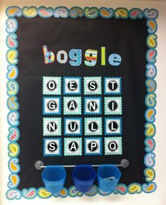 | Play bingo!!  Recap words - drip, droop, drown, crept, crash, cramp, brim, brown, bloom, blue, frown, fresh, frost, float.  Separate piece of paper into 6 sections and choose 6 words the list. Ask your parent to be a bingo caller and read out known words at random then mark off the spelling to match the word!

