|  |  |  |  |  |
| --- | --- | --- | --- | --- |
|  | English | Maths | Science | Topic |
| Monday | This week we want you to have a go at writing your own fact file! Just like the African one we made.  Have a think about something you are really interested in e.g. a game, an animal, a place.  Make a spider diagram about everything you already know about it. After write some questions about what else you would like to find out about your chosen topic. (Remember to include the correct punctuation at the end of your questions!) | **Measurement- litres (l)**  <https://www.bbc.co.uk/teach/supermovers/ks1-maths-capacity-volume/zj8njhv>  Children are introduced to litres (l) as a standard unit for the first time.  **Task**  Children need to be able to see the difference between 1ml and 1l. Gather up as many different containers or objects as you can that are measured in litres. Use smaller containers to investigate how many are needed to fill a larger container, comparing ml and l. Try estimating first.  **E.g I wonder how many litres it takes to fill a paddling pool or a sink?** | This week we are going to explore the human body!! We are going to look at the growth of the human body and healthy eating.  Humans go through different stages of growth in their life. Could you draw a timeline to show the different stages of human growth?   * Baby * Toddler * Child * Teenager * Adult * Elderly | **Geography –**  Human and Physical geography.  Human geography is something humans have made in the world e.g. a house, office, road, car park.  Physical geography is something natural in our world e.g. beach, ocean, sea, a hill.  Have a look on your walk and name as many human/physical geography features as you can!  https://www.twinkl.co.uk/resource/t-tp-896-ks1-physical-and-human-geography-glossary-powerpoint |
| Tuesday | Do lots of research on your chosen topic for your fact file. This can be using the internet, books or you could ask your grownups what the know! | **Measurement – ml and l**  Gather up a selection of items and put them into 2 groups – those you measure in ml and those in l. Create a table for your results.  Using <, > and = create some number or word sentences to compare your items.  **e.g.**  The capacity of the teaspoon is less than the capacity of the cup.  10 ml < 50 ml  The volume of the jug is 500 ml and then volume of the bottle is 1l. The volume of the bottle is larger than the volume of the jug. | Discuss your timeline with your parents and write down answers to the following questions.  How many years does it take for babies to grow into teenagers?  When do we start adulthood?  What changes can you identify from an adult to the elderly?  Write down the differences between each stage of human growth. | **PE-** Create your own obstacle course and fitness stations and time yourself to complete it. Estimate how long it will take you. Can you beat your time?  Why not challenge your family?  Before you begin, think of 2 stretches and 2 heart raiser exercises and teach them to your family. |
| Wednesday | Using your own knowledge and research can you create subheadings and bullet points on what you will include in your fact file. Remember your bullet points should be short, snappy and to the point!  For example, if I am writing a fact file about Sharks my subheadings might be.  ‘’How many different types of sharks are there?’’   * 440 types of sharks * Great white sharks * Whale sharks. Which are the biggest.   ‘’Where do sharks live?’’   * In different oceans around the world.   This will help organise your research for when you come to write your fact file! | **Measurement –temperature**  Children are introduced to temperature, thermometers and the units ‘degrees Centigrade’, written ℃ for the first time. They  learn that the temperature is higher when it is warmer. They apply their counting in 2s, 5s and 10s skills when reading different scales on thermometers.  If children have access to a thermometer, let them investigate how to use it. What happens to the numbers on the thermometer? How and when do they change?  Encourage them to use the vocabulary – increase, decrease, warmer, colder, difference.  \***for ideas see below.** | It is very important for humans to maintain a good diet and this can be through healthy eating. This means eating the right foods that will provide the human body with vitamins and minerals that it needs to survive.  What sort of food do you think is healthy? What will benefit our bodies? Can you think of any foods you may already eat that makes your body feel healthier? What foods don’t make your body feel healthy?  Draw a grid and separate into 2 columns. Write a list of foods you think are ‘healthy’ and foods you think are ‘unhealthy’. | **DT –**  This week we would like you to get involved with shopping and cooking. Choose a recipe to help to cook a healthy meal for your family. You will need to make a shopping list (don’t forget your commas) and then follow the recipe.  Don’t forget to take some photos and let us know how it tastes! |
| Thursday | Plan your fact file  Title –  Subheadings –  Paragraphs -  Pictures –  Captions for pictures –  Have a look at the one below to help! | **Measurement –**  See the investigation below involving the thermometer. | Look at the grid below (see appendix 1 for printable A4 example).    Suggest ways in which this person can improve their diet. Do they have too much sugary or fatty food? Are they eating healthy sometimes? What is healthy food and what isn’t? How can it be changed to benefit their body? | **PSHE –**  Introduce your parents to some of the circle time games we play such as ‘pass the smile’, ‘pass the squeeze, ‘pass the compliment’.  Discuss qualities of a good friend – What makes a good friend?  Discuss what we mean by:  -Helpful  -Caring  -Kind  -Gentle  -Respectful  -Resilient  -Resourceful  -Polite  -Well behaved  Have we shown any of these qualities since we have been learning at home? Share examples. |
| Friday | Write your fact file using your plan to help!  Don’t forget to organise your fact file using subheadings.  Make sure your fact file is attractive and include some drawings. | **Measurement –**  Can you solve the word problems below? Remember to show how you worked out your answer. | Draw some food that you would like to eat during a day of healthy eating. Draw them onto a plate and label them as a healthy menu.  For a good balanced diet, your menu should include:   * Fruits and vegetables * 2-3 portions of meat, rice or beans * 2-3 portions of diary food (milk, cheese etc) * No more than 1 sugary or fatty treat. | **Art**  Can you create a picture using outdoor materials!  Image result for outdoor materials art ks1  Image result for outdoor materials art ks1Image result for leaf picture ks1 art |



**Thermometer**

* Children could measure their own temperature and that of other family members. What do they notice? Do they think it will change after exercise? How? Children could then test out their theory and report on their results.
* Children could measure outdoor temperatures at certain times of the day. They could record the temperature at the same times every day and record their results. At the end of the week, the children could write about what they notice? Which day was coldest, warmest, comparing the difference in temperature on certain days or between mornings and evenings.
* <https://www.bbc.co.uk/bitesize/clips/z99ncdm>
* If children are able to access online resources, they can try reading a selection of thermometers.

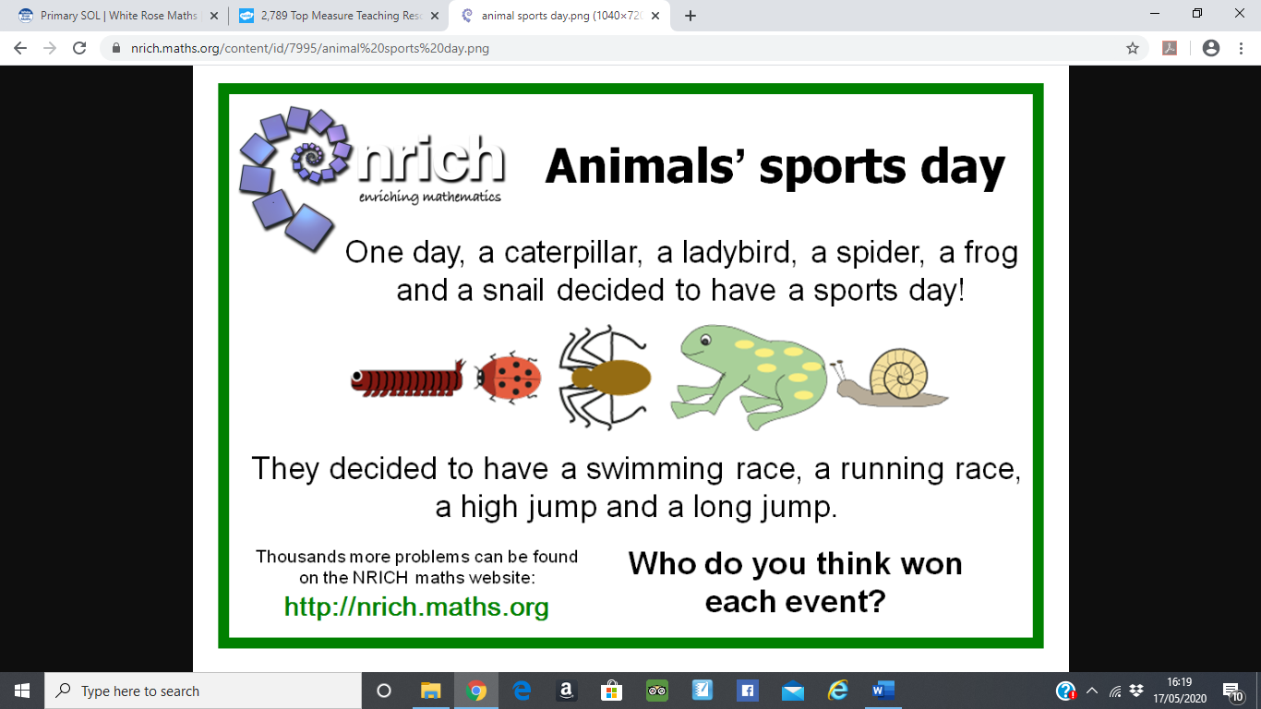**Thursday**

**Challenge:**

The next day four of the animals wanted another sports day, but the caterpillar had gone to sleep and would not wake up!

"When he wakes up, we'll have another sports day!" said the frog. The three others agreed.

Some days later the caterpillar did wake up. He crawled out of his sleeping bag. He looked quite different! How do you think this changed the race?

**Friday**

|  |  |
| --- | --- |
| 1. If Sarah drinks 2.5 litres a day, how much will she drink in a week? And a month? | In 1 week ………………….  In 1 month ……………….. |
| 2. Jenny needs to take 5mls of medicine, 2 times a day. How much will she take in one day? And in one week? | In 1 day ……………………..  In 1 week …………………... |
| 3. If one bucket holds 7 litres, how many would 9 buckets hold? | 9 buckets would hold ……………………. |
| 4. If a cup holds 250ml, how many cups would it take to fill a 2 litre bottle? | We would need …….. cups. |
| 5. At a party, Sam drank 200ml of lemonade, 600ml of cola and 300ml of orange juice. How much did Sam drink altogether? | Sam drank …………………. |
| 6. Jessie started with 1400 litres of orange juice and her friend drank 700ml. How much did Jessie have left? | Jessie had ……………… left. |

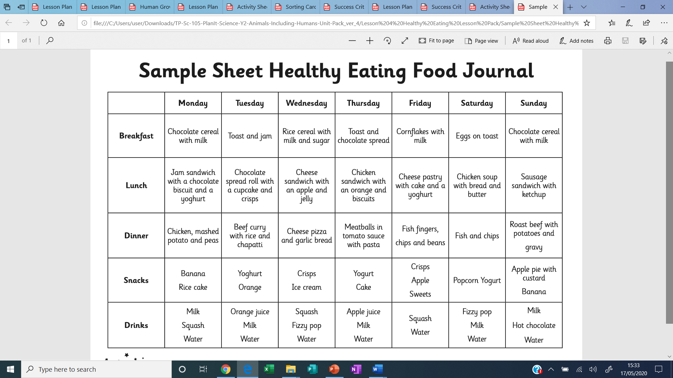**Appendix 1**