 | Miss Macleod’s  Group | Miss Clarke’s  Group | Miss Doughney’s Group | Miss Welch’s  Group
Monday | Homophones – words that sound the same but have different meaning and spellings.  Orally teach the clapping rhyme:  'A sailor went to sea sea sea'.  A sailor went to sea sea sea, To see what he could see see see, But all that he could see see see, Was the bottom of the deep blue sea sea sea.  Can you think of more words that do not have the same spelling or meaning? | Apostrophes (contraction)  Can you stretch out these contracted words?  We’ve  Doesn’t  Can’t  Shouldn’t  Wouldn’t  Haven’t  Didn’t  Can you shorten these words by replacing a letter or letters with an apostrophe?  Could not  Will not  We will  She is  They have  They will | Phonics Hunt  Become a detective and see how many objects you can find indoors and outdoors with the following graphemes:  ee, y, igh, i-e, ai, eigh, u-e, au, ph, wh  Make a list of words for each sound.  Why not write the word in chalk or make your own word labels? | Recap sound and spelling of split diagraph u-e.  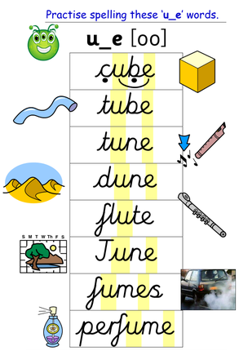  Can you write one of the u-e words into a sentence or think of your own u-e word to write in a sentence?
Tuesday | Ask a grown up to dictate some sentences to you, using the homophone pairs that you came up with yesterday.  e.g. I blew up a giant blue balloon.  The brave knight could only come out at night.  Remember to check your punctuation. | Words with ‘o’ that sounds like ‘u’:  Mother  Brother  Other  Come  Some  Month  Another  Money  Worry  Love  Above  Practise saying and spelling these words. Can you find any of your own?  Try them in a sentence. | Fluency and comprehension  Your task today is to learn a piece of writing, a story, a song or a poem by heart and read or sing it aloud. It must be something new that you don’t already know well.  Get some tips from The Worst Witch:  https://www.bbc.co.uk/teach/supermovers/ks1-english-reading-aloud-with-the-worst-witch/zh6cpg8 | Recap sound and spelling of split diagraph e-e.  Practise spelling these words – Pete, theme, extreme, concrete, even, delete.  Have a go at writing some sentences with e-e word sin.  Pete went to a theme park and rode the extreme rides.  The floor is made from concrete.
Wednesday | Write down as many homophones as you can on pieces of paper. For each word, draw a picture to remind you of the meaning of the word.  Let’s have a competition!  Now turn over the pieces of paper.  Take turns to pick a piece of paper and turn it over.  Read out the word and see who can write a sentence out quickest. | Hard ‘c’ and soft ‘c’  Can you put these words into the correct column?  Hard c Soft c  e.g. cat cell  Calling, pace, crumb, cease, ice, disgrace, cymbal, trace, cushion, acid, catastrophe, unicorn, crystal, carry, climb, certain, card. | Spelling Bee  https://www.bbc.co.uk/teach/supermovers/ks1-english-the-spelling-bee-with-bertie-bee/zkwvmfr  Host your own spelling bee.  Use the new words that you found last week.  Ask a grown up to read the words first. Then you repeat the word, spell out the word and then say it again.  Can you learn to spell this word? | Recap the alternative sound for ‘u’.  Write these words: pull, put, full, bull – unit, human, music, awful.  Read words on sight and discuss meanings.  Discuss what is the same and what is different about the ‘u’ words?  Write sentence – The music was awful.
Thursday | Contractions:  Can you shorten these words and add in an apostrophe ‘ to replace the missing letter or letters?  Do not  Have not  Should not  Could not  We will  He will  She will  You are  I would  Why not try to make a foldable word game to help you? See the images below.  Try using the contractions in sentences. | Hard ‘g’ and soft ‘g’  Can you put these words into the correct column?  Hard g Soft g  e.g bug giraffe  Groan, energy, ginger, grey, magic, giggle, gentle, gem, rage, allergy, grip, piglet, stage, danger, grunt, stag. | Ask your grown up to challenge you with a word of the week. You must try and use the word as much as possible in the next 7 days. Maybe you could set up a reward chart to record each time you use the word.  Here are some ideas:  Tomfoolery  Abracadabra  Gobbledegook  Kerfuffle  Shenanigan  Skulduggery  What’s the strangest word you can find and what does it mean? | Recap the alternative sound for ‘c’.  Play splat!!  Write words on small pieces of paper, spread out on floor and read words at random then splat correct spelling to match. (car, coil, could, cell, ice, city, celebrate)  Write sentence and check - There was ice on the car window.
Friday | Possessive apostrophes:  If something belongs to someone, we say that it is their possession. When we write it down we add an apostrophe and an s like this – ‘s  e.g. This is Sarah’s toy car.  You will need to create your own ‘ apostrophe.  Next you will need to write out your own sentences about things that belong to people.  Now add in your apostrophe and rewrite your sentence with the correct punctuation.  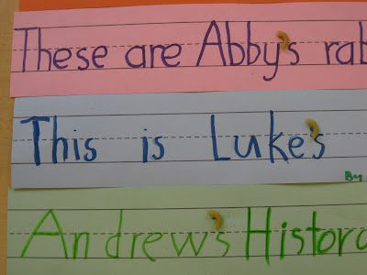 | How many different graphemes can you remember for the ‘ai’ sound?  ai, eigh, ay, a-e, ei, ey  Create a table with columns and see how many words you can think of for each grapheme.  Can you spot any patterns to help you to remember which one to use?  Try your new words in sentences to help you. | Prefixes  Look at the prefix table below and learn what each prefix means. Can you add to the examples of words with a prefix?  Write a sentence for each prefix. | Recap the alternative sound for ‘g’.  Quickwrite – girl, goat, grunt, great, age, gentle, gem, giant.  Read words on sight and discuss meanings.  Discuss what is the same and what is different about the ‘g’ words?  - Write sentence – The huge giant was gentle.

