 | English | Maths | Science | Topic
Monday | This week we would like you to write a diary. People write diaries about the things they do each day and how they feel.  Remember if you are writing a diary it needs to be in the PAST tense. For example- played, watched, ran, worked.  Remember to include as much information as possible about your day and don’t forget capital letters, finger spaces, punctuation and exciting vocabulary!  You could add a picture for each diary entry. | Statistics (revision)  Your task today is to collect data from your PE task. Try as many of the options as you can:  1)Create a tally chart for how many times you complete each exercise in 30 seconds.  2)Create a pictogram of your tally data (remember to scale it, if your numbers are large).  3) Create a bar chart of your tally data (remember to scale it, if your numbers are large). | Continuing to look at the human body, we are going to look into exercise and what impact it has on our bodies.  Discuss with your parents what exercise is?  Can you carry out some small exercises?  Describe what changes you can feel in your body.  Why do you think exercise is important? | P.E:  Can you make a mini circuit and choose different exercises?  Ideas of what you could include in your circuit:  Star jumps  Run on the spot  Jumping then touching the floor  Sit ups  Balancing  Don’t forget to warm up before and stretch after.
Tuesday | Write your Tuesday diary entry.  Can you add some exciting adjectives to your diary entry?  For example: Today I ate some scrumptious, fruity ice cream. | Measurement challenge  Compare the Cups (Nrich)  For this challenge, you will need lots of different cups.  Which might you choose if you wanted a lot to drink? Why?  Which one would you choose if you did not want a lot to drink? Why?  Could you arrange the cups in a line from the one that holds the most liquid to the one that holds the least liquid?  How will you test whether you are right? | Use your researching skills to find out how exercise affects:  - The heart  - Your muscles  - Your body  - Your mood  Write down some bullet points for each. | Design Technology:  Choose some of your favourite foods and do some research about where these foods come from and how they are made! See what facts you find out…
Wednesday | Write you Wednesday diary entry.  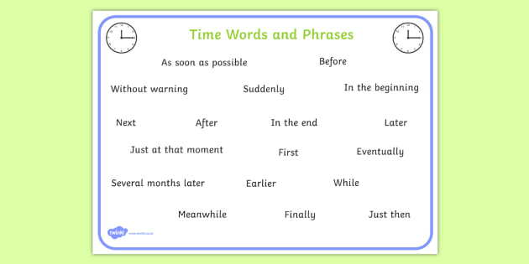  Could you challenge yourself today and add some time connectives? | Place Value Challenge (Nrich)  Create a set of digit cards from 0 – 9  Can you arrange them to make:  Largest even number  Largest odd number  Smallest odd number  Largest multiple of 5  Number closest to 50  You may only use each card once.  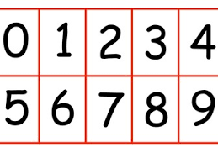 | What kind of exercise do you enjoy?  Think about what kind of exercises you might like to learn?  Can you make up your own exercises?  Do you exercise daily?  Use the grid below to record your exercises and discuss how your body is feeling. (See appendix for A4 printable version)  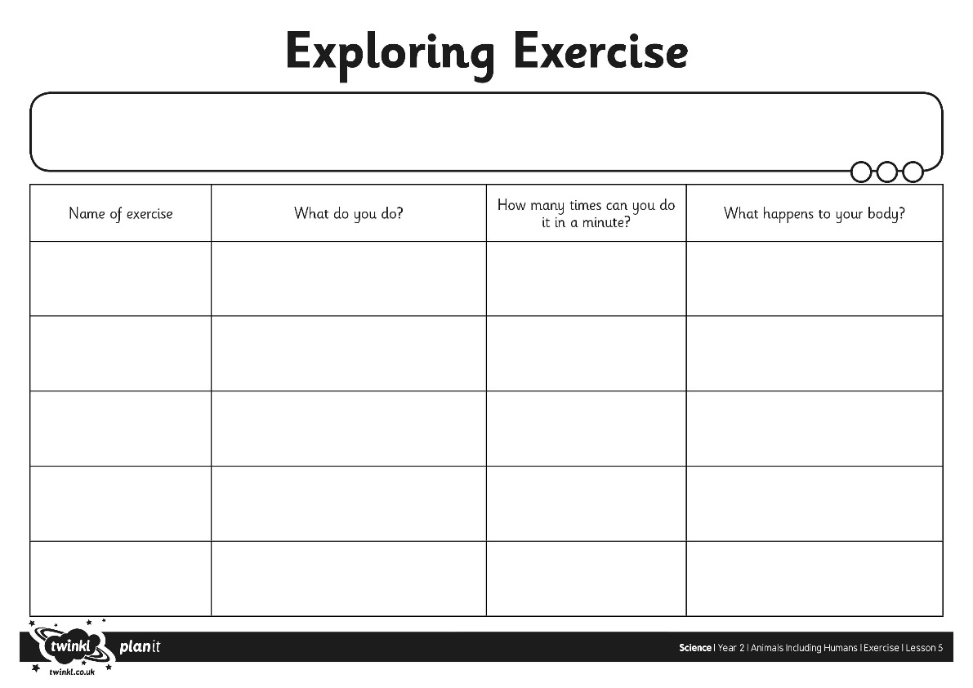 | Outdoor Learning:  Scavenger hunt (See Below).
Thursday | Write you Thursday diary entry.  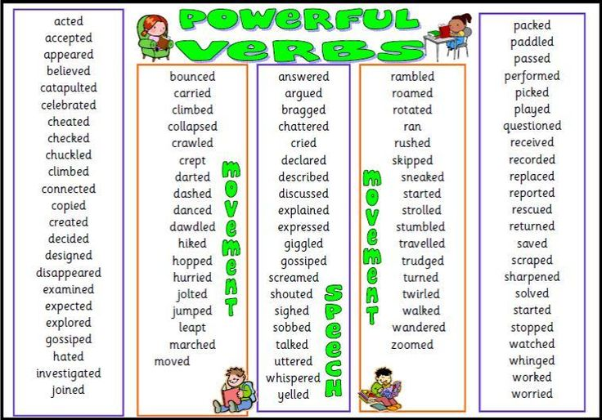  Can you add some ‘powerful verbs’ to your diary? | Addition and subtraction Fact Families  Create as many 2-digit + 2-digit number sentences as you can, using numbers from 10-99.  Solve the calculations.  Can you now make them into subtractions?  e.g.  44 + 12 = 56  12+ 44 = 56  56 – 12 = 44  56 - 44 = 12 | Exercise is important for lots of different reasons but it is also fun…  Why not try and make your own mini circuit with equipment you can find at home or in your garden?  Find some ideas below:  - Dancing  - Gymnastics  - Ride a bike  - Swim in a pool  - Football  - Running  - Jumping  - Play pass and catch | History:  Although the Olympics has been postponed this year…  Use your researching skills to find out information about the Olympics.  Research:  - What the event is.  - Countries that partake in it.  - What sports are involved.  You may enjoy watching some clips on youtube.
Friday | Write your Friday diary entry.  Can you extra challenge yourself to include past tense powerful verbs, exciting adjectives and time connectives today!!  If you really wanted to impress your grownups try adding a simile too! For example:  Today I played outside and the sun felt as hot as lava!! | Magic Number Tricks (Nrich)  Digit Addition  Here's a maths trick to try:  Think of one of the numbers from 1 to 9.  Add 9 to your number.  Add the digits of your answer together. What is your new number?  What do you notice?  Try the trick again with a new starting number. What do you notice now?  Jonas tried the trick with a few different numbers. He said:  I think you will always get back to your original number, because adding 9 is the same as adding 10 and subtracting 1.  Do you agree with Jonas? Can you help him explain what's happening? | Write a daily diet and exercise grid for one week that could help a friend/brother/  sister/parent.  Think about:  What food would provide a balanced diet?  What are healthy foods?  What exercises would be beneficial for their body?  What exercise they might enjoy?  How often they may need to eat?  How often they may need to exercise? | Art:  Complete some observational drawings of spring/summer flowers.  Pick some flowers from your garden or a local walk… place them on your table and analyse it closely.  What can you see? What colours are apparent? What is the shape like?  Draw the flower using a pencil and use coloured pencils to add detail.

Please send us photos of your child working or of their work and we can add it to the Facebook gallery, it would be lovely to see what they do!

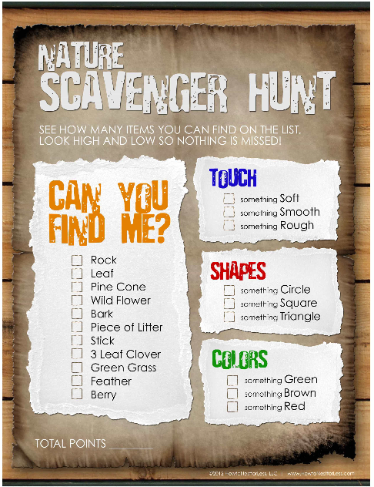

Statistics (examples)

Tally chart Pictogram Bar Chart
