|  |  |  |  |  |
| --- | --- | --- | --- | --- |
|  | English | Maths | Science | Topic |
| Monday | 1. What can you see in the above picture?   2. What can you predict/infer from the picture? | **Number of the Day**  Choose a number of the day and complete the worksheet below.  **Can you create number stories for your number(s)**  **e.g.**  **5 x 5=**    **25**    100-75= 1 more  Than 24 | **Density Tower**  You will need:  Tall glass or small vase Water Food colouring Cooking oil Sugar/honey/syrup Small items from around the house   1. Mix food colouring into 50-75ml water, mix honey into 50-75ml water until dissolved. 2. Slowly pour the honey water, coloured water then oil into the glass – leave abit of space at the top. 3. Try dropping small items in one by one – what do you notice? 4. Where do the particular items stay? You should notice some items will always stay in certain liquids – why is this? | **P.E**  Have a mini sports day at home with your family. Have a think of all the different activities e.g. race, egg and spoon race, jumping race, chucking an object into hoops for points etc. |
| Tuesday | Watch the first 65 seconds of this clip. What can you work out about Usain from this?  <https://www.literacyshed.com/usain.html> | Time (Hockey)  Read the time problem below and show how you worked out the problem. Use digit cards to help you.  It might help to work methodically.  Extend   "If there are 24 possible different halftime scores what could the final score have been?" | **Fireworks in a Glass**  You will need:  A small glass  Warm water  Cooking oil  Food colouring   1. Fill the glass with warm water 2. Pour a small amount of oil into another container and add food colouring 3. Give it a stir, if it doesn’t mix, add a bit of water 4. Pour the food colouring and oil mixture into the warm water and watch the fireworks!   Can you discuss why you think this reaction has occurred? | **D.T.**  Can you make your own healthy snack – make a iist of ingredients and ask a grown up to help prepare your snack!  E.g. fruit skewer, salad, healthy soup, healthy pizza! |
| Wednesday | Watch up to 3m 39s - How is Usain feeling now? How do we know this? Write a paragraph in the 1st person describing these feelings. | **What’s the time? (Nrich)**  Can you put the clocks below in order?  It might help to separate the clocks, so that you can move them around.  **Extend**:  Would it make a difference if some were am or pm? How? | **Dissolving**  You will need:  Water (hot and cold)  Small glasses  Substances to try and dissolve (salt, sugar, sand, coffee etc)  Make a prediction to whether you think your substances will dissolve in hot or cold water or both.   1. Add a teaspoon of whatever solid you are testing to a small glass of cold water and a glass of hot water. 2. Observe to see if the substance dissolves in hot and cold water or just one water and not the other. 3. Discuss why you think this is. 4. Can you record your observations in a table? | **Art**  Pretend you have been asked to design Great Britain’s Olympic Kit! Think carefully about what colours you will use. You could do this for a few countries that take part in the Olympics! |
| Thursday | Look at this picture again – can you write expanded noun phrases and similes to describe Usain?  Expanded noun phrase – He is a brave, confident and fast Olympian.  Simile – He can run as fast as a panther. | **Time game**  **Stop the clock (nrich)**  <https://nrich.maths.org/6071>  You can play this with an adult with a clock or against the computer.  See the rules below | **Lava Lamp**  You will need:  Water Vegetable Oil A Clear Plastic Bottle or Jar Food Colouring Effervescent (energy) Tablets   1. Fill the bottle or jar a quarter full with water. 2. Top up, almost to the top with the vegetable oil 3. They should separate into two layers, water at the bottom and oil sitting on top. 4. Add about 6-8 drops of food colouring once the oil and water separate. 5. The colour will mix with the water at the bottom. 6. Pop in half an effervescent (energy) tablet and watch the bubbles form. 7. Add more effervescent tablets bit by bit to keep the bubbles rising and falling. | **Music**  Listen to some national anthems - these are played when athletes win a medal at the Olympics. Your task is to create your own national anthem (with or without words) to play for a medal winner at the Olympics. You can improvise with instruments or use an instrument you have at home.  **https://www.kiddle.co/v.php?q=national+anthems** |
| Friday | Create a biography on Usain – you can use the film clip to help and complete your own independent research. | **Times table recap**  Can you recite your 2,3,5,10 times tables?  Maybe you know more.  Play a game of times table bingo. | **Grow a Rainbow**  You will need:  Kitchen roll/paper towel Felt-tip pens Two small bowls of water Paperclip Thread   1. Cut the kitchen roll into the shape of a rainbow. 2. At each end, use the felt-tip pens to colour a rainbow about 2cm up from the bottom. Remember the order of the colours: red, orange, yellow, green, blue, indigo, violet. 3. Attach the paperclip to the top of the rainbow and tie a piece of thread to it. This will allow you to hold your rainbow. 4. Add water to the two bowls. 5. Hold the rainbow with both ends slightly submerged into each bowl of water and watch your rainbow grow. | **PSHE**  Split a page into two columns and write ‘friend’ in one column and ‘unfriendly’ in another column. Discuss with your parents the qualities of a good friend and note them down. Then discuss what attributes an unfriendly person may have.  What’s different? What qualities would you like to see in your friends or new friends you may meet in the Junior school? |

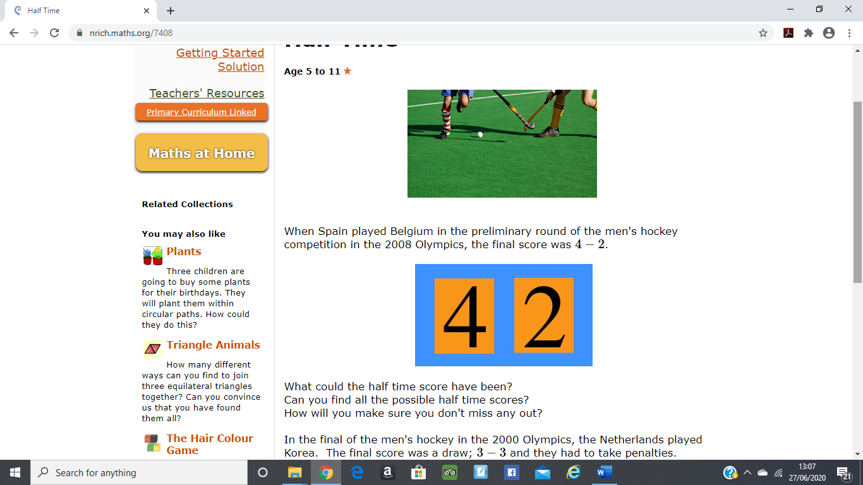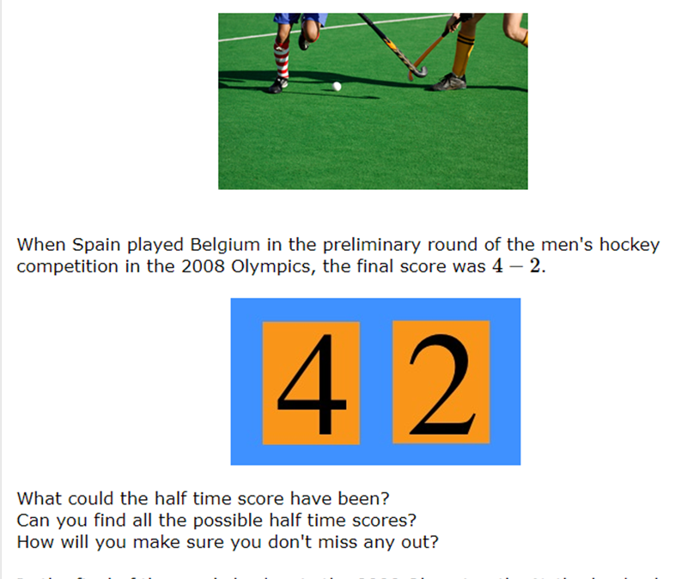

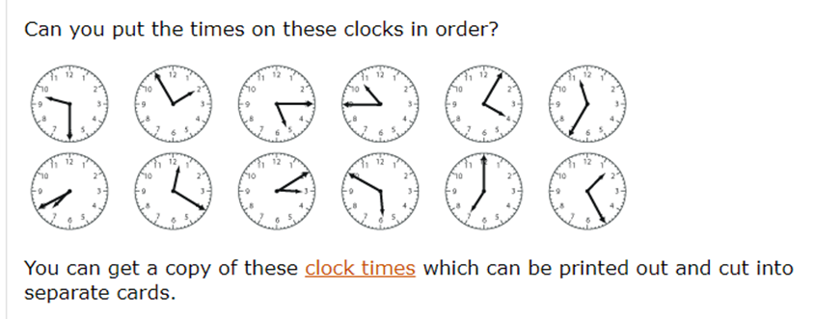

**Stop the clock**

This is a game for two players.

Set the time on the clock to 6 o'clock to start the game.

Decide who will go first (player 1) and who will go second (player 2).

Take it in turns to choose to move the hands of the clock on by 12 hour or by 1 hour. For example, player 1 could choose 12 hour, so the clock hands move to 6.30, then player 2 might choose 1 hour, moving the clock hands to 7.30... etc.

The winner is the player who moves the hands exactly onto 12 o'clock.

Can you work out a winning strategy so that you can always beat your opponent?