 | English | Maths | Phonics | Topic
Monday | Watch the video clip below about non-fiction and fiction texts.  https://www.bbc.co.uk/bitesize/topics/z2yycdm/articles/zty8xfr  Can you write some features of fiction texts?  Can you write some features of non-fiction texts?  (Check attached worksheets to help)  Can you think of some examples of fiction and non-fiction texts? | Counting in 2’s  Join in with Bridget the Lioness to count in 2’s!  https://www.bbc.co.uk/teach/supermovers/ks1-maths-the-2-times-table-with-bridget-the-lioness/zrrx92p  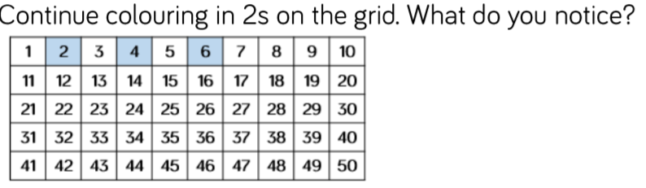  Can you use household items to count in twos (e.g. socks) Group the items into twos then try counting up in twos! Show your grown-ups when you are done.  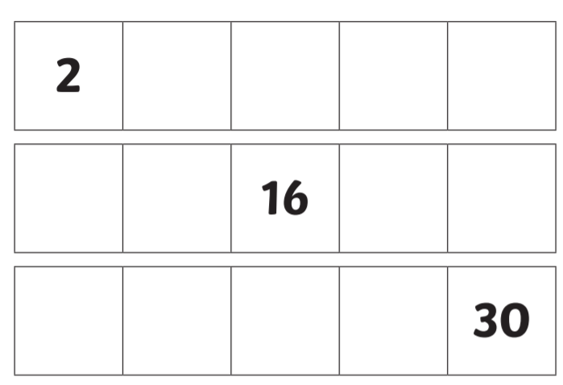  Fill in the blanks counting in 2’s! | Introduce the sound ‘qu’.  Write some ‘qu’ words e.g. quick, queen, quit  Have a go at writing some ‘qu’ words of your own.  Can you put each word into a simple sentence? | R.E  Think about what we have learned about Christianity.  Read Noah’s Ark story – https://www.youtube.com/watch?v=QAsfOcGjgoM  Discuss with grown-ups why it is important to protect our planet. Identify ways in which we can protect the planet. What things will destroy the planet?  Create a poster telling people what we must do to help ‘save our planet’
Tuesday | Thinking about the features you were learning about yesterday can you read the attached ‘Non-Chronological Reports (Non-Fiction Texts)’ about pirates and beaches then label the features.  Can you label:  Main Title (tells you what the report is about)  Subheadings (Mini-headline about the section or paragraph)  Diagram (images/pictures)  Labels (Label diagrams)  Can you write 3 facts from the Pirates and Beaches Non-Chronological reports.  What is a Sub-Heading?  A Sub-Heading is a mini-headline given to a subsection or paragraph within a main piece of writing. They are smaller in size than the main headline but larger than the paragraph text of the article.  What is a Fact?  Something that gives us real information. | Counting in 3’s  https://www.bbc.co.uk/teach/supermovers/ks2-maths-the-3-times-table/z6sw382  Fill in mising numbers in the attached counting in 3’s worksheet!  Ask you grown ups to listen to you counting in 3’s! Can you do a ‘mini’ 3 times tables test? | Introduce the sound ‘ou’.  Write some ‘ou’ words e.g. our, sour, about, cloud, proud, loud. Can you add sound buttons?  Have a go at writing some ‘ou’ words of your own.  Can you put each word into a simple sentence? | Science  Linked to your research about Ocean Creatures – can you think about their habitats?  Think about what a habitat is? What must they need to stay alive? Why is the ocean a suitable habitat?  https://www.bbc.co.uk/bitesize/topics/zx882hv/articles/zsfkd2p
Wednesday | We are going to be writing a Non-Chronological report about Sea Creatures!  Can you research what sea creatures are?  Can you make a list of sea creatures that interest you?  Why do they interest you?  Try to use bullet points to list your research  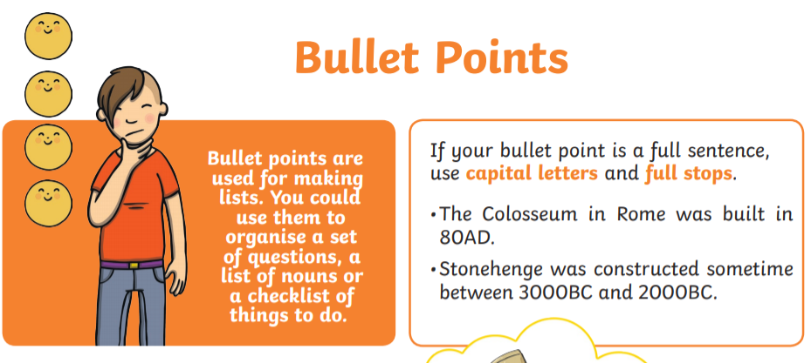 | Counting in 5’s  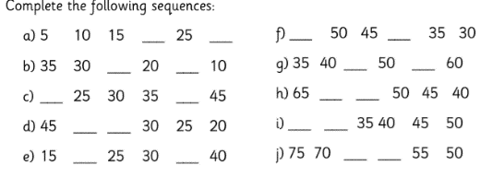  https://www.bbc.co.uk/teach/supermovers/ks1-maths-the-5-times-table/zhbm47h | Practise reading some of our tricky words.  Was, I, he, she, the, me, be,  Can you write these words into sentences?  Play bingo!!  Separate piece of paper into 6 sections and choose 6 words from the list. Ask your parent to be a bingo caller and read out known tricky words at random then mark off the spelling to match the word! | Geography  In geography we are thinking about our Local Area… Can you draw a map of Ryhope? Try to include our school, the beach, sea, and other key parts of the village.  Use map symbols to identify key parts on your map!
Thursday | Thinking about the sea creatures you listed yesterday can you make further your research today making mind maps about 3-4 sea creatures that interest you most! Try to find as many interesting facts as possible about your sea creature! Think about what people will want to know! Tell whoever is at home all about the facts you have found.  (Worksheet attached below) | Counting in 10’s  https://www.bbc.co.uk/teach/supermovers/ks1-maths-the-10-times-table-with-webster-the-spider/zm32cqt  Count in 10’s with your adult at home!  Ask an adult to test you with your 10 x tables.  Asking 1 x 10  3 x 10 etc.  Can you fill in the blanks? | Introduce the sound ‘ie’.  Write some ‘ie’ words e.g. lie, pie, tie, pies, skies, lies. Can you add sound buttons?  Have a go at writing some ‘ie’ words of your own  - Can you put each word into a simple sentence? | PSHE  Talk to a grown up about how it feels to start new school, class, group, club etc.  Think about all the feelings you may feel… How did you overcome these feelings? Write a list of emotions you felts  Think about if a new child was starting our school. What things can we do to make the new member of our school feel welcome?  Create a poster Welcome to Year 2!  And include key features that a new child would need to know if they were joining our school.
Friday | Reading Comprehension. Today we would like you to read the ‘’All about Autumn reading attached’’  Can you answer these questions after you have read it?  - What season does Autumn come after?  - When does Autumn begin?  - When does Autumn finish  - What do hedgehogs do during Autumn and Winter?  - Can you name 3 foods that harvested during Autumn?  - What date is Halloween celebrated?  - How is bonfire night usually celebrated? | Can you solve the problems?  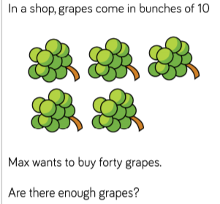  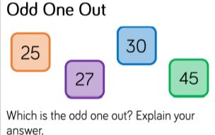 | Recap the tricky words from this week and copy each word onto a small piece of paper.  Play splat!!  - Spread your flashcards out on the floor and ask your parent to read words at random then splat correct spelling to match. | P.E  Practise some of our important P.E skills – balancing, running, jumping, hopping.  Can you play the ‘bean game’ with a grown up at home?

