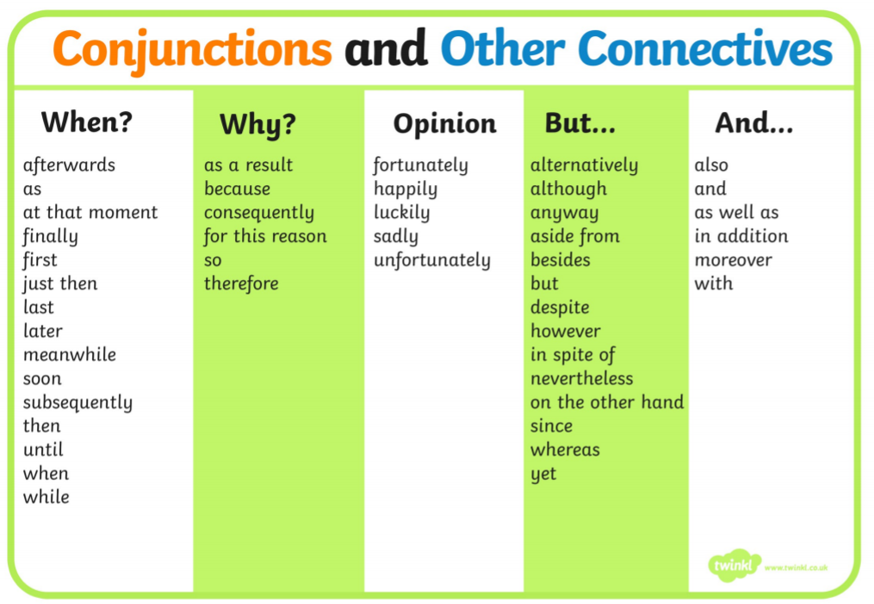

Science

Crab
Use this word bank to label the picture of a crab.
legs | shell | eyes
claws | antennae

Challenge: Write some sentences to answer these questions.
Is a crab an invertebrate or a fish?
What does invertebrate mean?
Can a crab breathe underwater? How?
Can a crab survive on land? How?
How does a crab move underwater?
How does a crab stay safe from predators?

Octopus
Use this word bank to label the picture of an octopus.
eye | tentacles | suckers
mantle | siphon

Challenge: Write some sentences to answer these questions.
Is an octopus an invertebrate or a fish?
What does invertebrate mean?
Can an octopus breathe underwater? How?
Can an octopus survive on land? Why?
How does an octopus move underwater?
How does an octopus catch its prey?

