 | English | Maths | Phonics | Topic
Monday | https://www.youtube.com/watch?v=PFZiw3Eq3EY&t=106s  Can you write sentences to describe life as a trapper boy? Use ‘senses’ to help. | Counting Pound and Pence –  When counting pound and pence ensure to count your pounds then count pence.  Count the highest amount then add on…  See attached work sheet! | Tricky words – Practise Phase 4 Tricky Words  Writing  Look, cover, check  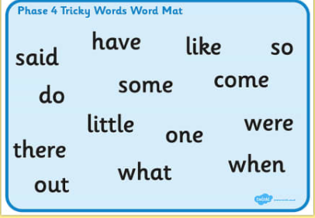 | History:  Research mining – what was the point of mining? Why was it important in Ryhope 100 years ago?  What did mining get?  Research coal? – what was the main purpose of coal? Why was it so important?
Tuesday | Similes  https://www.bbc.co.uk/bitesize/topics/zmfc7ty/articles/zrrhpg8  Watch the video to understand what similes are. Can you use similes to describe life in the mine.  For example…  The coal mine is as dirty as a muddy field.  It is cold like an ice cube. | Make the same amount using different combinations.  Can you make the same amount of money using different coins?  If you have coins at home you can do this practically. If not please see attached worksheet – circle the money to make different combinations! | Can you put the tricky words into a sentence? | Science  Can you try your own science experiment of planting seeds?  Put them in different conditions and predict which flowers will grow, which wont grow etc.
Wednesday | Questions and exclamation!  Use this punctuation in your writing today ‘?’ question marks and ‘’!’’ exclamation points.  First decide whether these sentences need an exclamation point or questions mark-  Why do I have to work here  Why is he so unkind  This coal mine is freezing  That man is horrible  When is it home time  Will it be light or dark when I get out  Once you have finished that can you write your own questions and exclamations. | Find the total of two different amounts!  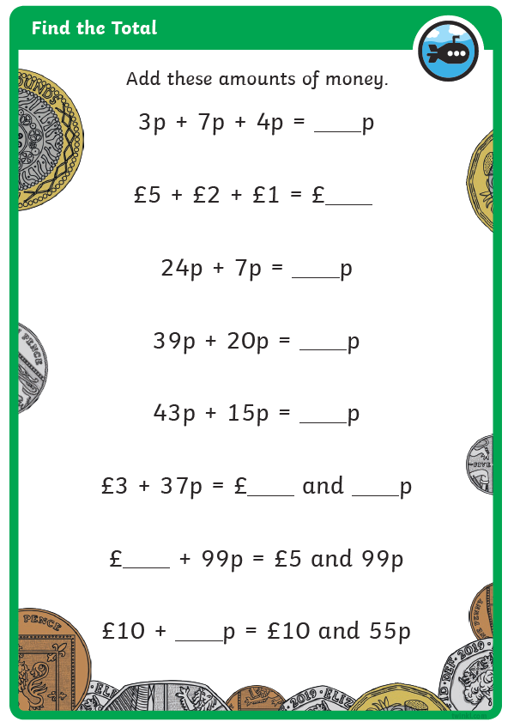 | Can you put the tricky words into a sentence? | P.E  Can you express you dance movements using different body parts? Put the dance moves into a sequence.
Thursday | Can you write a diary entry using the skills you have learned last week and this week about a trapper boy working in the mine | Finding the difference –  Work through problems | Practise writing phase 5 tricky words.  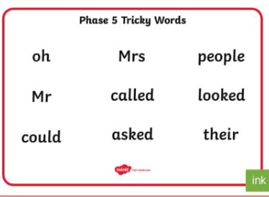 | R.E:  Diwali  https://www.youtube.com/watch?v=KZU6M4EisyA  Can you write what you have found out about Diwali
Friday | Write a diary entry about your time off school.  Remember to use time conjunctions – First, second, then, next, after. | Finding the difference –  Work through problems | Can you write phase 5 tricky words into sentences? | ART  We are focussing on Ray Lonsdale in art.  Can you try to recreate/sketch/make this creation by him.  