 | English | Maths | Phonics | Topic
Monday | This week we are going to be writing a letter to the people in charge of Trapper Boys who worked in the mines. Our job is to try persuade them to STOP children working in the mines!  Today we would like you to plan your letter.  - Think of your opening sentence, who are you writing to and why?  - Think of arguments why children shouldn’t be in a mine e.g. scared, hurt, should be in school, should be playing etc.  - Think of how you would conclude your letter.  (Use these to help with your sentence openers)  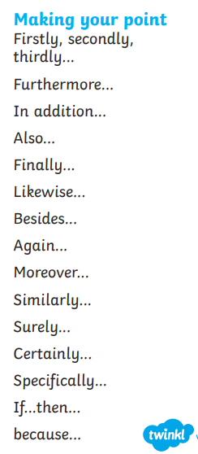 | Finding the difference. Today we would like you to find the difference between amounts of money.  (Remember when we find the difference we subtract)  How much more?  I have 2p. I need 4p. How much more?  I have 5p. I need 10p. How much more?  I have 3p. I need 5p. How much more?  I have 6p. I need 12p. How much more?  I have 10p. I need 20p. How much more?  Challenge.  I have 20p. I need 30p. How much more?  I have 50p. I need 70p. How much more?  I have 25p. I need 35p. How much more?  I have 60p. I need £1. How much more | Split diagraph. Read and shade real and nonsense e-e words  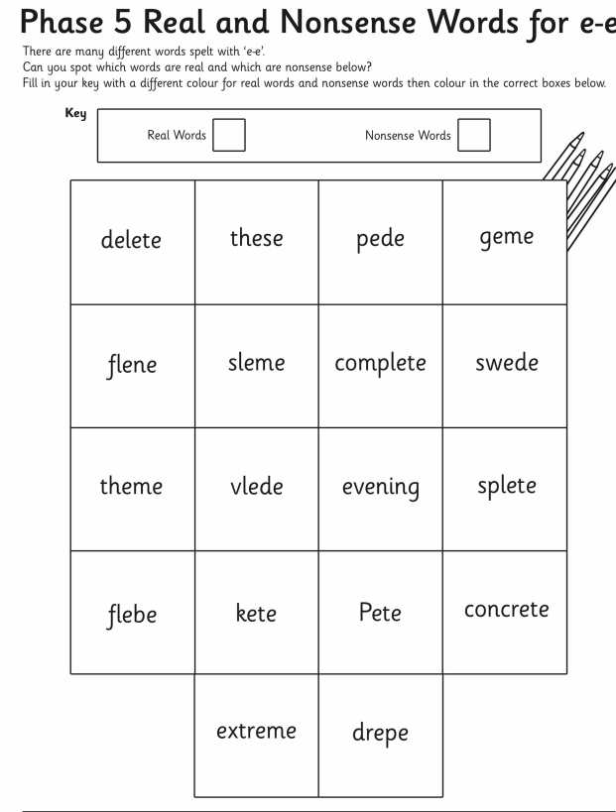 | History  Have a think about the tools miners would use. Can you label the tools attached (linked to what the Beamish man told us)  Think about what they were used for and why they were used.  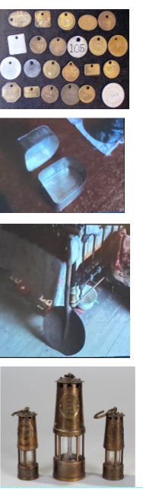
Tuesday | Today we want you to think of synonyms to make your sentences powerful using the rule of three in your letter. Synonyms are words that mean the same things. E.g. happy, joyful, pleased. Sad, upset, unhappy.  Can you write synonyms for these words?  Nasty – e.g. bossy, unkind, unhelpful, bully  Scary – e.g. terrifying, petrifying,  Dark-  Sad –  Worried –  Upset -  Angry –  Then try apply them into sentences linked to your arguemtns you planned yesterday. | Finding the difference – continuing on from yesterday pick out the key maths vocabulary and numbers to find the difference in these maths problems.  Sophie would like to buy a board game which costs 20p but  she only has 10p. How much more money does she need?  Zachary would like to buy a box of chocolates which costs 50p  but he only has 30p. How much more money does he need?  Robin would like to buy a book which costs 31p but he only  has 21p. How much more money does he need?  Charlotte would like to buy a teddy bear which costs 45p but  she only has 25p. How much more money does she need? | Split diagraph a-e  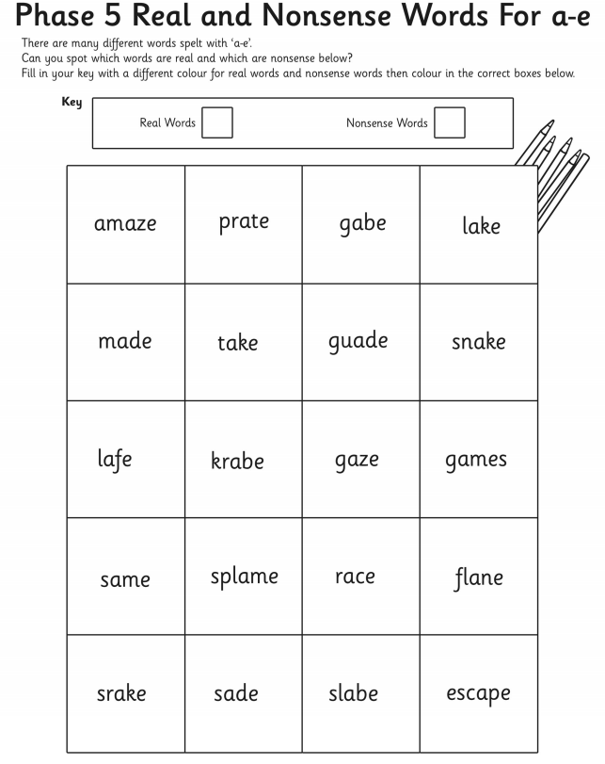 | Science  https://www.youtube.com/watch?v=p3St51F4kE8  Draw and Label parts of a plant.
Wednesday | Today we would like you to think of questions to include in your writing. Questions you would like to directly ask.  E.g. Would you like to work 12 hours a day in the dark?  Why can’t these poor children eat?  When will they be free?  Why do you chose children to do these jobs? | Finding the difference:  Izzy would like to buy a ball which costs 50p but she only has 30p. How much more money does she need?  Robin would like to buy a book which costs 90p but he only  has 50p. How much more money does he need?  Charlotte would like to buy a teddy bear which costs 85p but  she only has 65p. How much more money does she need?  Finley would like to buy a yo-yo which costs 77p but he only  has 60p. How much more money does he need?  Ella would like to buy an ice cream which costs 52p but she only  has 30p. How much more money does she need?  Leon would like to buy a puzzle which costs £1.00 but he only  has 50p. How much more money does he need?  Suzie would like to buy a lollipop which costs £1.50 but she only  has £1. How much more money does she need?  Rupert would like to buy an Xbox game which costs £1.20 but he only has 80p. How much more money does he need? | Split diagraph  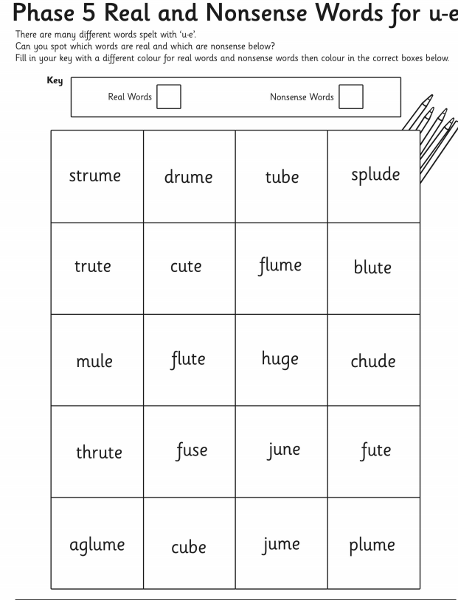 | R.E  Create your own advent candles – research what each candle represents.
Thursday | Today we would like you to write your letter thinking about the things we have learned this week! | How much change?  ps://www.topmarks.co.uk/money/toy-shop-money  Have a go at practically playing this game working out how much change is needed. | 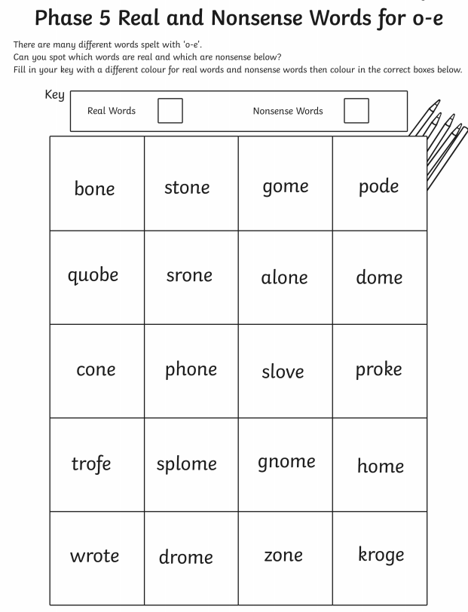 | ART  Sketch the miners wheel
Friday | Write a diary entry about your time of school – don’t forget to include time conjunctions. On Friday, morning, afternoon, then, next, later etc. | How much change?  Have a go at the worksheet attatched working out how much change is needed. | Split diagraph  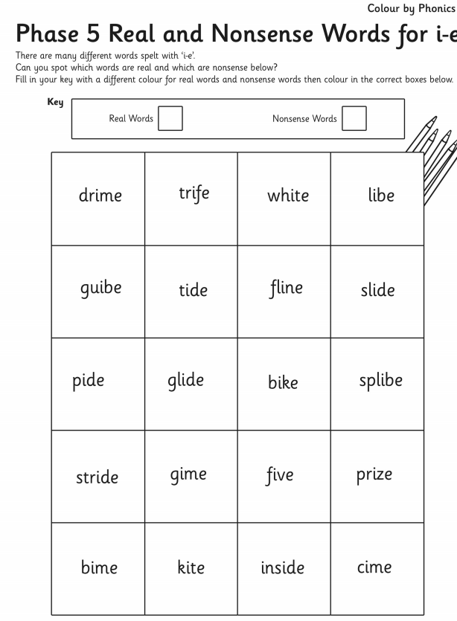 | P.E  Dance can you put dance moves together to form a sequence.

