 | English | Maths | Phonics | Topic
Monday | Today in school we are having an arts and crafts day creating props for a Christmas window. Our challenge to you is to create your own Christmas window at home and write instructions to match. | Today in school we are having an arts and crafts day creating props for a Christmas window. Our challenge to you is to create your own Christmas window at home and write instructions to match | Today in school we are having an arts and crafts day creating props for a Christmas window. Our challenge to you is to create your own Christmas window at home and write instructions to match | Today in school we are having an arts and crafts day creating props for a Christmas window. Our challenge to you is to create your own Christmas window at home and write instructions to match
Tuesday | See attatched worksheet to correct the punctuation in the sentences.  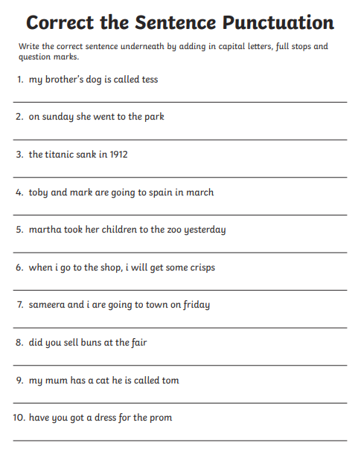 | Measuring using CM  Use a ruler to measure the chocolate bars (see attatched worksheet) you could use the ruler to measure other objects in your house too!  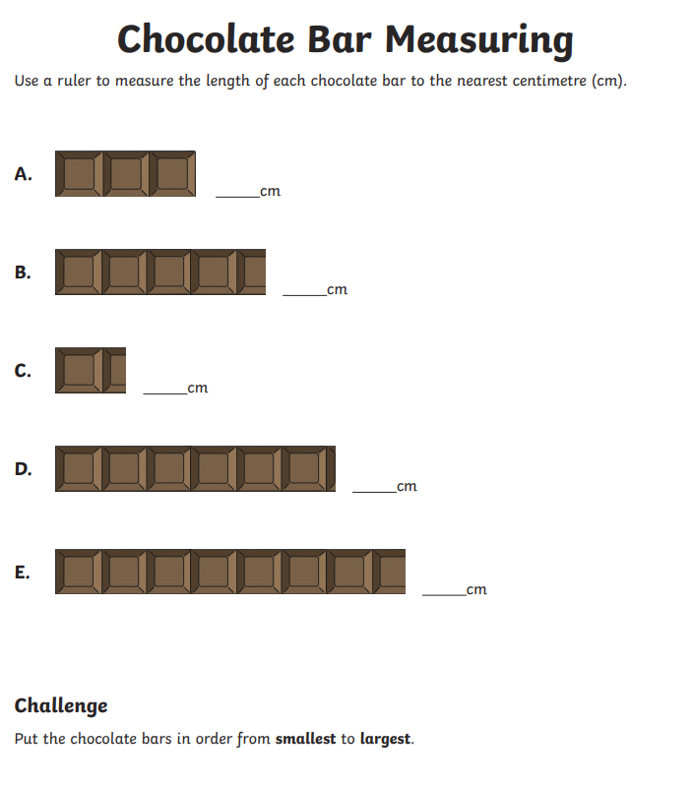 | (Remember to use active learn to access phonics games too)  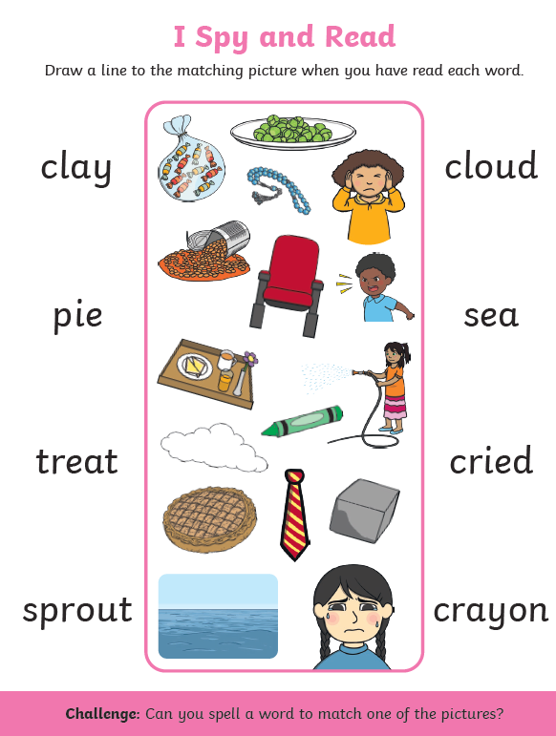 | History – compare household objects that we use now compared to what was used in the past.
Wednesday | Use your knowledge of adjectives to describe the monster.  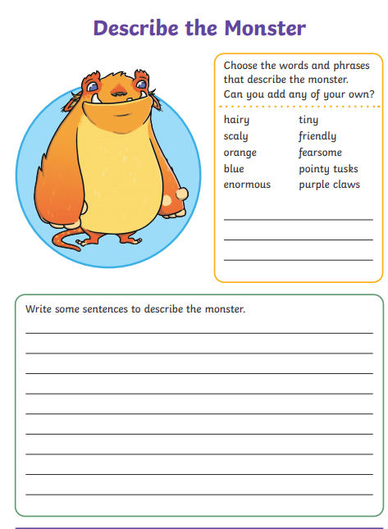 | Measuring  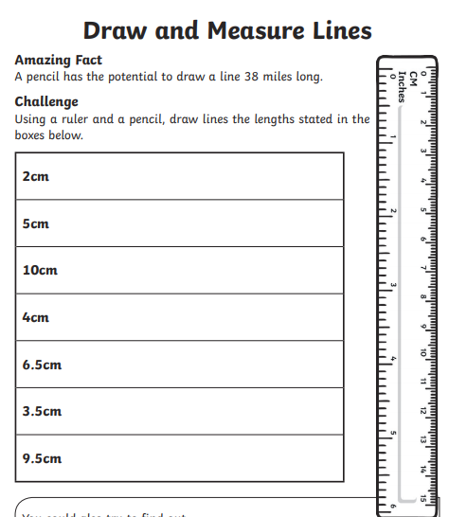 | 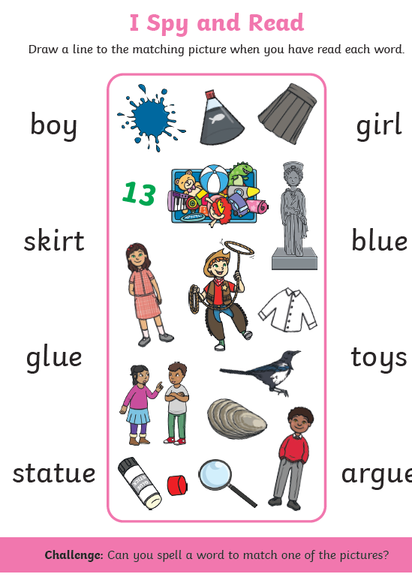 | Science –  Think about plants we eat – can you list some that you know of?  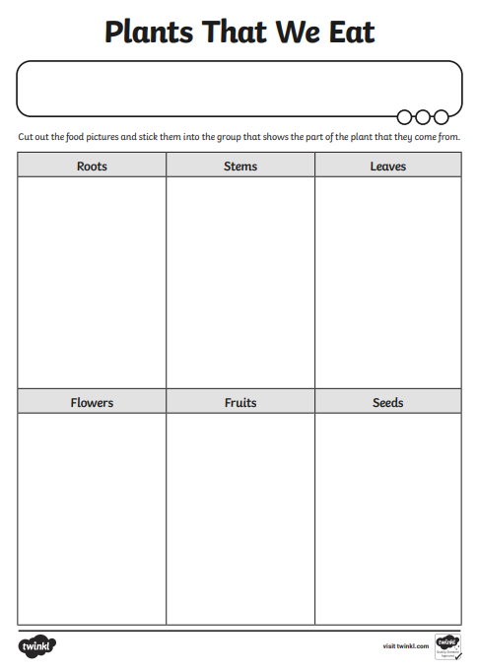  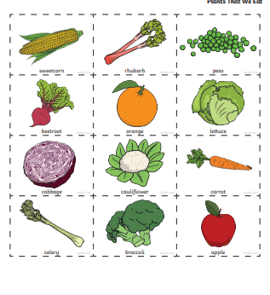
Thursday | Correct the spelling mistakes.  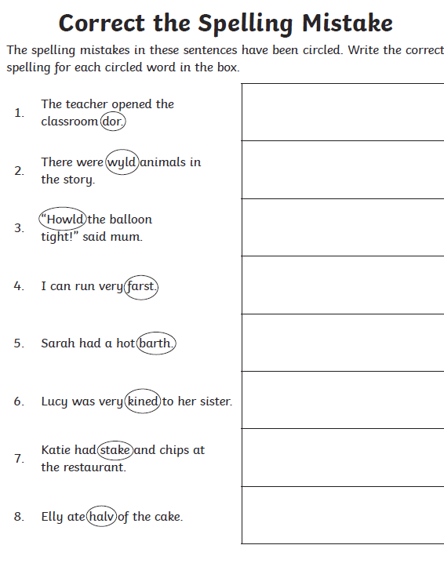 | Measure objects in your homes – record the measurements and order them smallest to largest! | 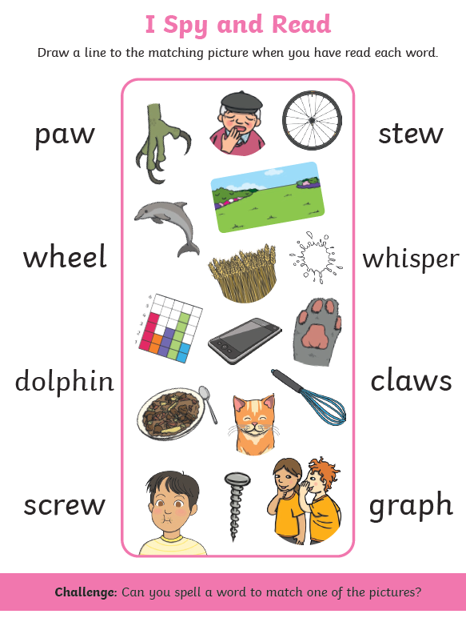 | R.E  Decorate your own advent wreath.
Friday | Can you write a diary entry about your time off school? Remember to include, adjectives, time conjunctions (First, second, next, then, after that) | Practise your counting in 2’s, 3’s, 5’s and 10’s.. you could use objects to help! | 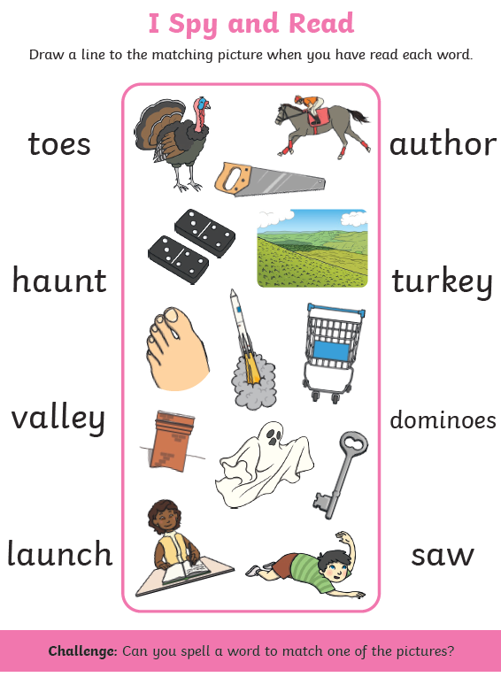 | Art- Design a Christmas calendar.

