 | English | Maths | Phonics | Topic
Monday | Look at the picture below can you think of 5  qestions you want to ask about it?  Can you then make some inferences about the  picture. E.g. what time of year is it? How do you  know? What time of day is it? How do you know? What else can you work out from the picture.. | Measurement problems:  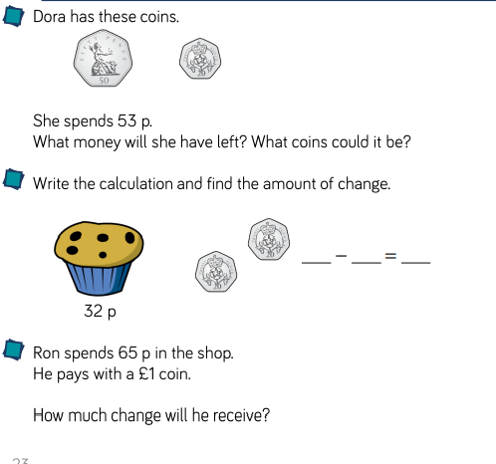 | 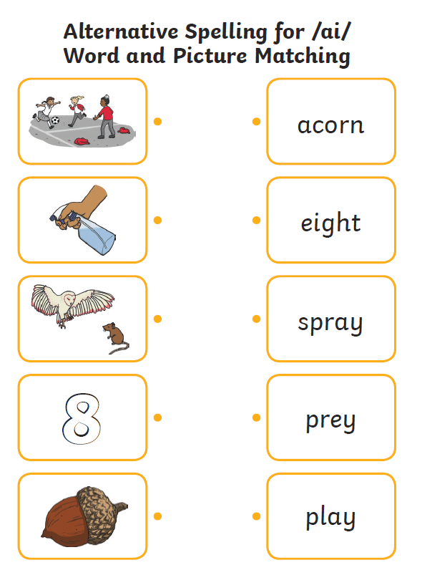 | Science:  Can you plant your own seeds and conduct your own plant experiment?
Tuesday | Can you use adjectives to write a scene desription about the below picture?  Remember adjectives are describing words. | Making equal groups.  Use objects at home (this could be toys, pasta, beads, marbles etc.)  Can you make equal groups of 2, 5, 10, 2, 4 etc. and add them in repeated addition.  Making equal groups worksheet-  See attached (building bricks) | Can you put the tricky words into sentences  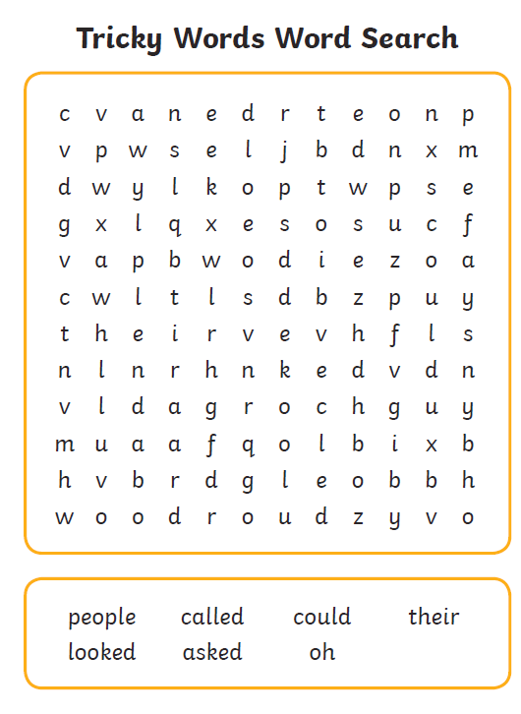 | R.E:  Christmas story – watch the below clip and create a story board to show the charismas story.  The First Christmas Tree (A Short Christmas Story) - Bing video
Wednesday | Look at the below picture – can you think about how each character is feeling? Use description and explain why you think they are feeling in this way. | Making equal groups  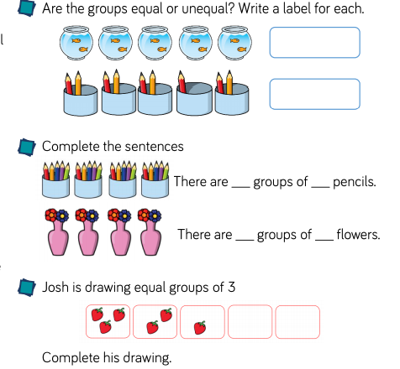 | 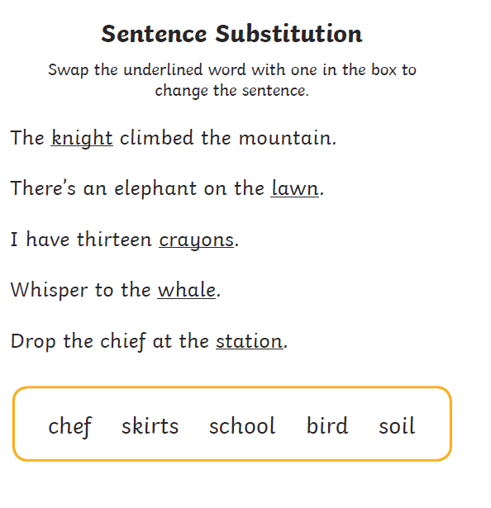 | History:  Can you think about the questions you asked at the beginning of our history topic about Ryhope 100 years ago.  Write as many facts you have learned about it.
Thursday | Imagine you are on the polar express train… What would you see?  How would you feel?  What would you hear?  What might you taste? | Add equal groups  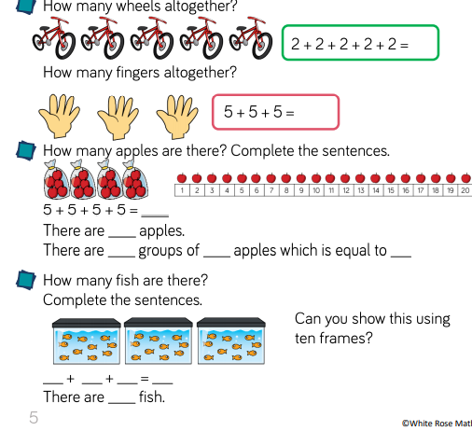 | 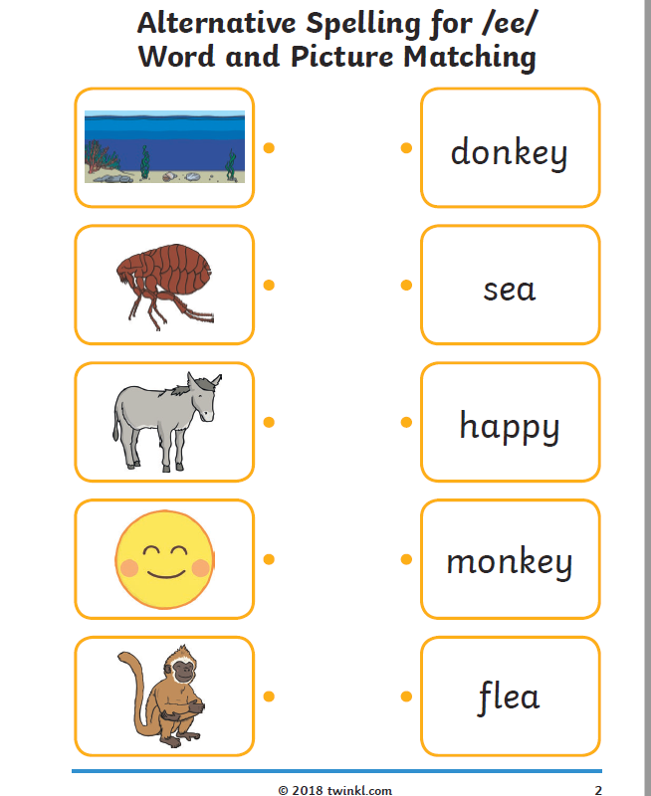 | ART  Can you make your own Christmas calendar at home?
Friday | Write a diary entry about your days off school. Can you use time conjunctions to order it and adjectives to describe. | Arrays – see attathed | 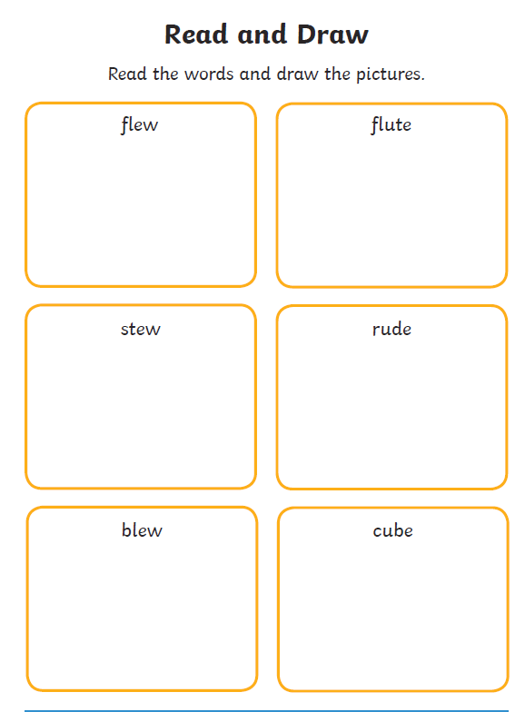 | Music:  Practise singing Christmas songs and keeping a steady beat.

