 | English | Maths | Phonics | Topic
Monday | At home can you make a sandwich/ cereal/ cakes? We will be writing instructions this week and would like you have a go! | Can you have a go at measuring out ingredients to make something at home. Have a think about what you are measuring in – grams, kilograms? | (see attached tricky word Christmas worksheets) | History.  Write a list of facts you have learned about Ryhope 100 years ago.
Tuesday | Can you write instructions about what you have made yesterday? Remember to use your bossy verbs. | Repeated addition and multiplication.  (See attached work sheet) | see attached tricky word Christmas worksheets) | Science:  Plants we eat (see attached worksheet)
Wednesday | Look at the picture.  What inferences and predictions can you make from it?  What questions do you have about the picture?  Can you predict what time of year it is? How do you know? | Colour by number subtraction/addition (christmas jumper) | see attached tricky word Christmas worksheets) | Design your own Christmas jumper.
Thursday | 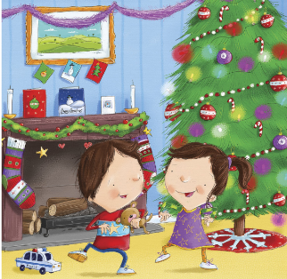  Can you write a description about the characters from this story? Think about why they are feeling the way they are? How do you know?  Remember to use your adjectives. | Christmas maths – add by crossing 10. | see attached tricky word Christmas worksheets) | Christmas Party Day!  Can you make your own dance at home!
Friday | Can you write a diary entry about your time off school? | Counting in 2’s maze | see attached tricky word Christmas worksheets) | Christmas crafts at home!

