Week beginning 25th January 2021
 | Morning | Afternoon
Monday | This week we are learning about Doctors! We will be reading the story ‘Topsy and Tim go to the Doctor.’ You can find an online version here:  https://www.youtube.com/watch?v=9vRveJfsD0o  Listen to the story and talk about what happens. Can you answer these questions?  Who felt poorly first in the story?  What was wrong with him?  Where did Mummy take Tim?  What did the doctor give Tim?  What happened to Topsy?  Have you ever felt poorly and had to go to the doctor? Can you write a sentence about what happened? (eg. I had a bad tummy / The doctor helped me / I got medicine from the doctor) Remember – your child only needs to have a go at writing the words the way they sound, so they may write ‘I had a bad tumee / The doctur helpt me / I got medisin from the doctur | 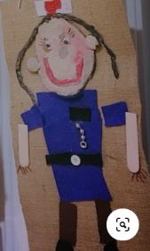  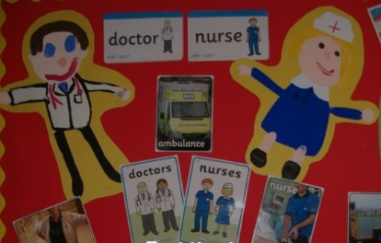  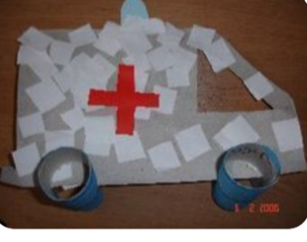  Creative – Today you could have a go at creating a doctor, nurse or ambulance! You could paint or use materials from around the house to make a collage. Remember to use the correct colours for uniforms and on any vehicles. Here are a few ideas, but you will find many more with a quick google search.
Tuesday | Maths – This week we are still mastering the concept of one more and one less.  To reinforce what you talked about last week, you could play a game of ‘I’m thinking of a number’ – Adult says ‘I’m thinking of a number that is 1 more than 7 / I’m thinking of a number that is 1 less than 11’ and child works out which number it would be. If they are confident with this, work with higher numbers (to 20) but if not stick to lower numbers (to 5 or 10). You could also have objects available to them to count out so that they can physically add one more, or remove one to check their answer.  Activity: download our ‘I Spy’ counting activity. Can your child count how many of each emergency worker there are on the page and write the corresponding number? Use this to talk about ‘more/ less’ by asking ‘Which has the most? Which has the least?’ | Understanding the World – this week was all about doctors and nurses. These people work at the doctor surgery, health centre or hospital. What do you know about what happens in these places? See what you can find out by looking in books or searching online.  You could draw a picture, build a Lego hospital, or make a junk model doctors surgery. Adults you could write down what your child says (this helps us to assess their understanding of the world around them, and things in it)  You might also like to watch this episode of ‘Do You Know’ which is all about how blood pressure monitors work and how plaster casts are put on!  https://www.bbc.co.uk/iplayer/episode/b07w577q/maddies-do-you-know-series-1-8-blood-pressure-monitor-and-cast
Wednesday | This morning we do an extra phonics session to practise and apply our phonic knowledge and we also read our books with our teacher  Use this opportunity to read one of your books on Book Bugs. You can also access the phonics games that have been allocated to you. | Physical:  This week have a go at developing your fine motor skills by practising your cutting. Download our doctors cutting activity and see if you can cut out the items and stick them in the bag.  If you don’t have access to a printer, you could draw your own doctors’ items to cut out!
Thursday | Remind your child of what they have learnt about ‘more / less’ and how ‘more’ simply means a bigger amount, and less means a smaller amount. We can also use this when learning about capacity. Capacity just means how much something holds.  Collect some various containers from around the house (different sized cups, bowls, pans etc) and ask your child which one they think would hold the most / least water. Test it out- you could count how many cups it takes to fill a small pan, then a large pan and compare.  Activity: Download the ‘more/less capacity sheet. Can you tell your grown-up which item will hold the most / least in each set of pictures? | PSED:  This week we are thinking all about the ways in which medical staff help us when needed. It is important to learn ways in which we can be helpful to each other. Talk about the many day to day ways that the people within your house help each other. Ask your child to think of some ways that they can be helpful towards people in their life.  Activity: Make a thank you card for somebody who has helped you.
Friday | Remind your child of Monday’s story about going to the doctors. You could listen to it again. Discuss the various things that doctors might use when checking and treating patients. Can you write a list of items that you might have in your bag if you were a doctor? (Plasters, medicine, syringe, thermometer, blood pressure monitor, pen and paper, prescription slips)  You can download our special doctor paper or use your own. | RE:  Last week we started to learn all about Bible stories. To tie in with this week’s theme of helping one another, we have chosen the story ‘The Good Samaritan’  You can watch an online video version here:  https://www.youtube.com/watch?v=aSfm2xdKau4  Talk about the story afterwards and point out the moral of the story – that it can be difficult to show care for the people who you do not get along with, but it is important to be helpful and caring to everyone!

