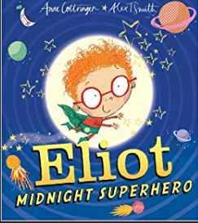
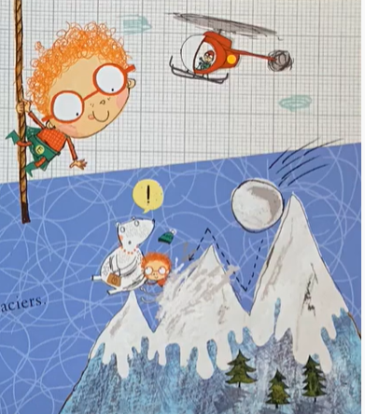
Wednesday - Predictions
Wednesday - Predictions
Wednesday - Predictions
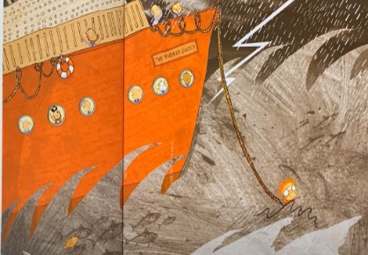

Thursday – Adjectives

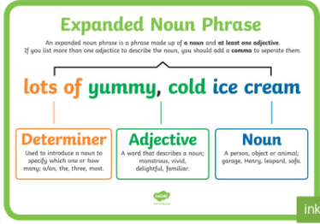
Friday – Expanded noun phrases
Wednesday – Multiplication

____ groups of ____ | Add it.  ___+___+___ =___
Say it.  There are ___ equal groups with ___ in each group.  There are _____ altogether. | Multiply it.  ___ x ___ =
Wednesday – Multiplication
____ groups of ____ | Add it.  ___+___+___+___ = ___
Say it.  There are ___ equal groups with ___ in each group.  There are _____ altogether. | Multiply it.  ___ x ___ =
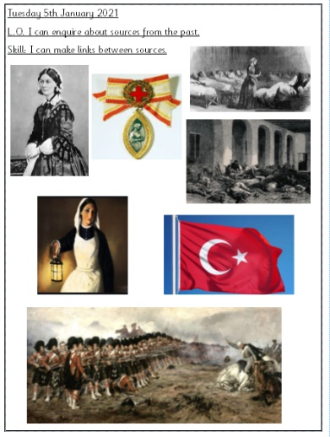
Wednesday - History
Thursday – RE

