 | English | Maths | Topic
Monday | Inset Day | Inset Day | Inset Day
Tuesday | School Closure | School Closure | School Closure
Wednesday | This term our topic is Superheroes!!  Take a look at the front cover of our first story we will be looking at (larger versions of pictures are in ‘resources’ download)  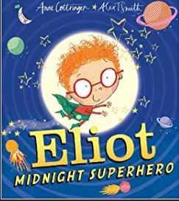  - What do you think the book will be about?  - Why do you think that?  - What time do you think it is? What clues are there?  - Read the title ‘Eliot Midnight Superhero’ – make a prediction what do you think the book will be about from this title?  - Does the book look exciting? Why?  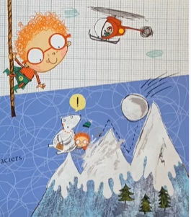  - What do you think Eliot is doing on the picture? Can you explain why you think this? (make sure to look closely at the picture). Start your sentences with ‘I think that…’  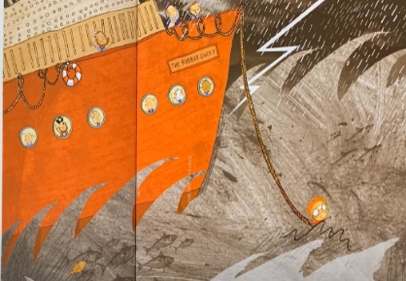  - Can you make a prediction? What do you think Eliot is doing on this picture?  - Can you give reasons for this giving evidence from the pictures to support your answer? | In Maths we are focussing on Multiplication and Division!!  Practise counting it 2’s in your head, on your fingers, using household objects like toys, pasta, marbles, beads etc.  Remember when counting in 2’s we are counting forwards in equal groups. Equal means the same amount in each group.  We are going to recap what we learned before Christmas:  Identifying ‘groups of’, adding groups together and saying our Maths out loud.  See attached sheet of Maths grid with box split into 4 sections:  Discuss images of 5 pencils in a box (x4) – Ask chn: What do you see? How many groups? How many in each group? How do we know it is a group?  Say it: 4 groups of 5.  Draw it: (counters/groups) 5 circles in each group.  Repeated Addition: 5 + 5 + 5 + 5 = 20  Commutative Multiplication: 4 x 5 = 20  Work through second sheet of different representations to the chn so they can see the relationship between repeated addition and multiplication. | History:  In history we are going to be focussing on real life superheroes!!  Your job as a historian today is to enquire about the past. Remember, the past is something that has already happened, it could be minutes ago, hours ago, days ago, weeks, months, years etc.  Please see the attached sheet through the ‘resources’ download.  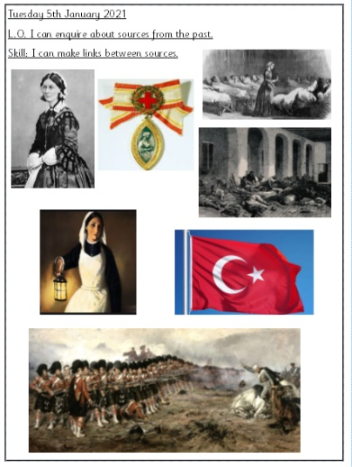  Write down some questions you would like to find out about the images? Or the real life superhero? Who do you think she is? Why is she significant? What is happening in the images? How might she have made a difference? Remember don’t race ahead and research the answers!! Just ask questions for today.
Thursday | Adjectives  https://www.bbc.co.uk/bitesize/topics/zrqqtfr/articles/zy2r6yc  Adjectives are describing words that describe a noun – for example: A colourful and beautiful flower.  The green, scary and ugly monster.  Complete the attached worksheet which shows you Eliot’s appearance. What does he look like? Write exciting adjectives to describe his appearance:  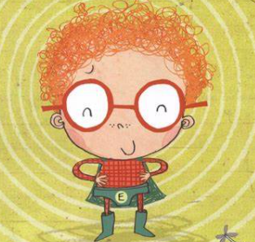  E.g.  - Hair - ginger, curly, frizzy, wavy  - Glasses - enormous, shiny, red, glossy  - Top  - Pants  - Boots  - Face  - Nose  - Smile | Practise counting it 5’s in your head, on your fingers, using household objects like toys, pasta, marbles, beads etc.  Remember when counting in 5’s we are counting forwards in equal groups. Equal means the same amount in each group.  This session is practical Maths!!!  Use sweets, money, pasta, marbles or grapes as your counters and bowls or plates as your groups – any small household objects that are safe to use.  Use resources to practically solve the multiplication number sentences below:  3 x 2 4 x 5 10 x 2 1 x 10 5 x 5 0 x 10  2 x 2 6 x 2 4 x 2 3 x 5 8 x 2 10 x 0  Chn to write number sentence on paper next to the groups.  Encourage language such as groups of, lots of, times, multiply. | R.E  Today we would like you to think about belonging. Linking in with our Christianity topic, Christians believe they belong to god. What do you think belonging means? Can you discuss this with your grown up?  Who do you think you belong to? Can you name people in your family? Do you belong to other homes than your own? Do you belong to a school?  Write down a list of where you feel you belong.  Discuss with your grown up about producing a family tree. Discuss your grandparents, then your parents, aunties, uncles, then you, brothers, sisters.  Can you make your own family tree and show us where you belong?  See attached sheet.
Friday | Expanded Noun Phrases:  Common nouns: These are the names of things (places or objects.  Proper nouns: These are the names of a particular person, place or thing. They always begin with a capital letter.  Adjectives: describe a noun.  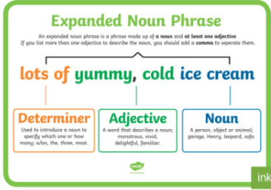  An expanded noun phrase is a phrase made up of a noun and at least one adjective. If you list more than one adjective to describe the noun, you should add a comma to separate them e.g. Eliot has huge, red glasses, Eliot has frizzy, ginger hair.  Can you use your adjectives you wrote yesterday and put them into an expanded noun phrase?  E.g.  Eliot has ginger, curly hair.  Eliot has pink, rosy cheeks and gigantic, shiny glasses.  Eliot has a long, green cape and pointy boots. | Practise counting it 10’s in your head, on your fingers, using household objects like toys, pasta, marbles, beads etc.  Remember when counting in 10’s we are counting forwards in equal groups. Equal means the same amount in each group.  Explain arrays to represent multiplication.  Arrays – drawing groups in rows or columns  e.g. 2 x 3  …  …  Discuss multiplications can be either way round but will produce  the same answer.  Draw arrays to match a multiplication:  3 x 2  4 x 5  6 x 2  3 x 10  4 x 2  6 x 5  Discuss language columns and rows. | PE  This afternoon we would like you to complete a session of PE with Joe Wicks!!  If you don’t have access to a computer… Make up your own exercises.  Do some stretching like we do in PE.  And lastly, enjoy your golden time!!

