Week beginning 1st March 2021
 | Morning | Afternoon
Monday | This week we are continuing with the story Bumpus Jumpus Dinosaurumpus. Here it is if you would like to here it again: https://www.youtube.com/watch?v=r_gk8KE8D8w We have made masks, described what we found and also explored sounds!  Today we are going to think about what it would been like where dinosaurs lived – show children some pictures of places (Photos to compare) – describe what you can see, which picture shows where dinosaurs might have lived? Why do you think that? Encourage your child to speak in full sentences and to give a reason why the dinosaurs may or may not have lived there.  Activity: today we are going to look at some of our dinosaur fact books and talk about what we can see/find out about dinosaur lands. If you don’t have dinosaur books at home you can use websites or watch videos.  Here is a site to get you started: https://www.kids-dinosaurs.com/dinosaur-facts.html  Either video or write down what your child finds out using books/website and send us it or maybe they can draw pictures of interesting things they found out.. | Understanding the World – this afternoon we are going to watch episode 1 of Andys Dinosaur Adventures to see what we can find out:  https://www.bbc.co.uk/iplayer/episode/b03wc5fl/andys-dinosaur-adventures-1-trex-and-pumice  Afterwards see if you can tell a grown up something you have learned about the T Rex dinosaur, maybe try drawing him? Can you remember what he looks like?  Ask your grown up to write a fact about T Rex that you remembered or maybe have a go at doing it yourself? We have sent you some dino paper for your picture!
Tuesday | 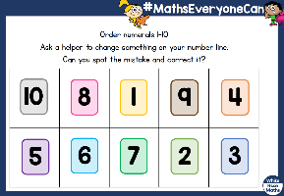  Today we are continuing with our learning about 10, you can watch the video lesson here: https://vimeo.com/506047182 We are learning about ordering numbers correctly and spotting numbers that might be upside down or in the wrong place.  Activity: print or make the number flashcards, have a go at putting them in the correct order, take away 1 or 2 numbers, what is missing? Put some of the numbers in the wrong order, can your child spot what is missing? | 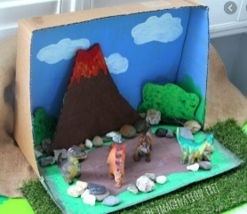  Creative –  This afternoon we are going to start to make a dinosaur land.  You can do this with things you find in your house or garden, stones/rocks and recycled materials like boxes and paper are good. Don’t forget to make a list of the materials you need before you make it. Please remember to send us a photo when you are finished.
Wednesday | Today we are going to talk about some of the dinosaurs from the story – we have chosen two that we can compare and talk about. We are practising describing what we can see and talking in full sentences. Look at the pictures – can you name some of the parts? What do you notice about the dinosaurs? Talk about how they are the same/different. Encourage your child to give information in a full sentence – This dinosaur is green and has stripes.  Activity:  See if you can draw/paint one of the dinosaurs, can you label any of the parts? You could use the words- tail, legs, nails, teeth, horns  We have also included a labelling sheet that you can have a go at.  Use your phonic knowledge to read the words and match them to the correct part. | Physical:  This afternoon we are going to use some dinosaur style moves to warm up. You can find a super warm up here: https://www.youtube.com/watch?v=ymgBTpNKHS0  In school we are continuing our work with low apparatus, can you set up your own obstacle type course in your garden? Things you have to jump/hop over, spaces where you need to run, objects you need to go under, over or around? Send us some photos, we would love to see them!
Thursday | Practise counting 0-10 and 10-0, grown-ups, ask your child to count how many claps/slicks you do.  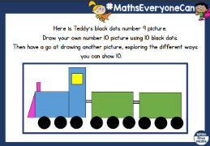  Today we are going to further explore how we can make ‘10’, watch the video: https://vimeo.com/506047565  Activity: can you draw your own picture showing ten items? Maybe to a garden with 10 flowers? A tree with 10 apples? | PSED:  Todays story is about believing in yourself. We are going to read Giraffes can’t Dance. Here is the story: https://www.youtube.com/watch?v=E92XNvCoeWo Gerald was scared to dance as he thought the other animals would make fun of him. He was worried about trying something new!  Listen to the story and then talk to your grown up about something you were worried about trying and when you did do it, you loved it! We would love to hear about it so send us a video or a message to let us know.
Friday | Place the number cards on the table, ask your child to find 5, 3, 6 etc. Can they find the number that is 1 more than 3? 1 more than 5?  Todays maths is about matching amounts to a numeral.  You can watch the video: https://vimeo.com/506048027  Activity: we have attached bingo boards for you to use or you can make your own – place the objects cards face down, turn over a card and the person with the matching numeral can put the card onto their bingo board. Who will be the winner? | 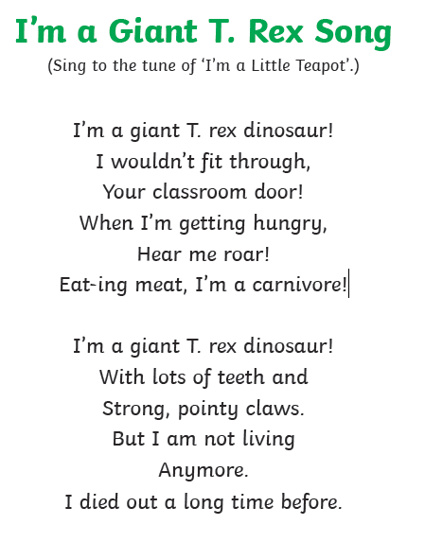  Music:  Last week we explored sounds and also sung a dinosaur song, see if you can remember last weeks song and then you can have a go at this one.  Maybe you can add in some actions and send us a video via DoJo?

