Week beginning 8th February 2021
 | Morning | Afternoon
Monday | English: This Friday will be Chinese New Year, so this week we are basing lots of learning around this festival. Give your child an introduction to the festival by watching these video’s on Cbeebies Let’s Celebrate:  Preparing for Chinese New Year  https://www.youtube.com/watch?v=c8ssHXZ9_qU  Celebrating Chinese New Year  https://www.youtube.com/watch?v=1cRMRp9-Z08  Discuss what you have found out about the festival and ways in which it is celebrated. Are there any similarities to our New Year celebrations?  Activity:  Can you draw a picture of something you have remembered from the video’s and add some labels, or write a sentence? (You could draw and label things like fireworks, a dragon, a money wallet or lantern). Remember, it is important to encourage your child to sound out the word and write it exactly as it sounds. | Understanding the World – We are taking part in the RSPB Big Bird Watch. Today we will learn about some common garden birds and make some bird feeders to encourage birds to visit our school grounds. You could do the same and hang them in your garden!  You can access resources on www.twinkl.co.uk for free at the moment. To learn more about the Big Bird Watch, have a look at this https://www.twinkl.co.uk/resource/t2-t-968-the-big-birdwatch-powerpoint or go to the RSPB website  https://www.rspb.org.uk/get-involved/activities/birdwatch/  We have uploaded some instructions on how to make a simple bird feeder and a garden bird checklist so that you can keep a record of which birds you see throughout the week.  You could also draw and label some pictures of any birds that you spot!
Tuesday | Maths: Today we are continuing our learning about the numbers 6,7,8. You can watch the next video (Session 3 – composition of 8) here: https://whiterosemaths.com/homelearning/early-years/growing-6-7-8/  Activity: Can you use the picture cards we have uploaded to sort 6, 7 and 8? Cut them out and mix them up, ask your child to look carefully at what the picture on each is representing and put them into piles of ‘things that show 6, things that show 7, things that show 8.  Activity: Alternatively, you could complete the ‘I Spy 8’ activity – circle all of the images that show 8.  You might also enjoy the Numberblocks episode ‘Meet Number 8’  https://www.youtube.com/watch?v=D9zgxdC7tQA | 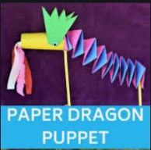  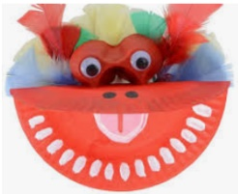  Creative – This week we will be having a go at a few different Chinese New Year themed crafts! You could choose from these ideas and have a go at  - A paper plate dragon  - A lolly stick and folded paper dragon of lion  - A paper lantern  You will find loads more ideas online!
Wednesday | This morning we do an extra phonics session to practise and apply our phonic knowledge and we also read our books with our teacher  Use this opportunity to read one of your books on Book Bugs. You can also access the phonics games that have been allocated to you. | Physical:  To get us moving this week we will be looking at dragon dances! This is an important part of the Chinese New Year parades that happen. Watch the video below and talk about how the dragon moves:  https://www.youtube.com/watch?v=P_l9AdCH2oM  Then follow the link below to a lovely song that will encourage your child to move in various ways that are linked to how Chinese dragons dance.  https://www.youtube.com/watch?v=by5sTzh67fU  Listen and follow the instructions. You could also find some traditional Chinese music on youtube and make up your own dance using coloured pieces of material or scarves. Think about making large and small, and high and low movements. We would love you to send us a video of your child joining in with this!
Thursday | Maths: Today we will be looking at the next unit of our maths work which is all about length. When we teach length we always start with comparing two items. (Always make sure you line up the two items at the base)  When talking about length with your child, ask them questions like ‘Which one is longer? Which one shorter?’ and encourage use of these words rather than just ‘bigger and smaller’  Gather a few items from around the house and discuss which is longest and shortest? Are there any that are the same length?  Activity: Cut out the Chinese Dragons and order them from shortest to longest. | 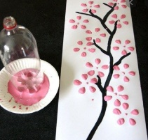  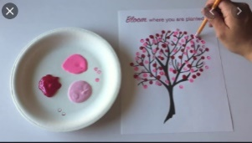  Creative- We are continuing with our Chinese New Year theme and today will be painting lucky blossom trees. You could print with the bottom  of a bottle (like in the picture) or use the end of a pencil or cotton bud to make small dots.
Friday | English: Today we will learn a story about the origins of Chinese New Year called ‘The Great Race’ You can find a video telling the story here: https://www.youtube.com/watch?v=eVClAj8q_lY  Activity: Can you sound out and write the names of the animals in correct order that they finished the race?  Activity: Write name in Chinese! Have a look at the Chinese alphabet that we have uploaded and see if you can find the symbols to represent each letter of your name.  Activity: Can you find out which animal represents this year? What about the year you and your family members were born? | Valentine’s Day:  As Valentines day is this weekend, today we will be baking some heart shaped biscuits. You can find a recipe to follow here https://www.goodto.com/recipes/iced-heart-biscuits  Cooking is a fantastic way to get your child involved in some real-life maths, counting out, weighing and measuring ingredients. We would love to see some photos of you having a go!  If you don’t fancy cooking, you could make a Valentines card or picture for someone that you love.

