 | English | Maths | Phonics | Topic
Monday | Exploring Poetry  Introduce poems to children and read together. Discuss layout of poems and format. Ask what content it includes - Nouns? Adjectives? Sentences? Rhyme? Short phrases and keywords? Discuss reading a poem with expression and actions and how it will help us remember it and be able to recall it effectively.  Poems - KS1 English - BBC Bitesize  (See Attached Literacy Poems to explore features of poetry) | This week we are starting to look at Fractions.  Draw 2D shapes for chn and find equal parts.  Discuss terminology ‘equal’ – what does it mean? How can we find an equal part?  Discuss the part and the whole of different 2D shapes.  Children to use correct language when referring to equal parts of a whole shape.  How many equal parts can you find within each 2D shape drawn? | Practise adding suffixes changing ‘y’ to ‘i’ (remember to say y-i!)  Adding the suffix ‘es’ to nouns to make plurals.  Write down as many nouns as you can think of ending in ‘y’. Now change the ‘y’ to ‘i’ and add ‘es’.  Fly, spy, cry, try, sky etc  Try your new words in sentences. | BRITISH SCIENCE WEEK!!  This week is British Science Week and we are exploring the topic ‘Design your own Robo Bug’ to link in with our habitat topic.  We need the boys and girls to think about what insects/mini beasts need to survive within a small microhabitat or within a large habitat.  Then think about the future – how could we make a robotic bug that would have excellent features to survive and be beneficial to its habitat and ecosystem.  Get your thinking caps on and have a go at designing your own robo bug!!  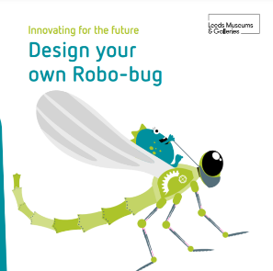
Tuesday | This week we are going to be writing our very own poem for mother’s day about someone special in our life – this could be for mam, nanna, auntie, sister, dad, grandad.  Show mother’s day poem - Discuss contents included in a poem such as rhyming couplets, similes, adjectives, use of commas etc. Ask children to pick out some examples of these.  Identify the adjectives in the poem e.g. beautiful, wonderful, joyful, kind, caring.  Ask children to decide who they are writing their poem for and to begin writing some adjective to describe the special person in their life. | Finding ½ of a shape.  Draw 2D shapes – square, circle, triangle, rectangle, hexagon, pentagon, kite.  introduce terminology ‘half’ ½ - What do we mean by a half? Split into 2 equal parts.  Is the rectangle split into equal halves? How?  Discuss ½ with chn and what each denominator and numerator stands for. 1 – part shaded … 2 – how many parts the shape is split into.  How many halves make a whole?  Model drawing shapes and children splitting them into equal parts. | Adding ‘ing’ to verbs that end in ’y’ (e.g. cry, try, copy, fry, dry).  How many verbs can you think of that end in y?  This time you can just add the suffix ‘ing’. E.g. copying  Add ‘ing’ to your own verbs and use them in sentences.  You could ask your grown up for a sentence that you could borrow. | Create camouflage animals – think about what camouflage is. Why is it important for survival for animals?  Test yourself to create a camouflage animal and ask your grown up to try find it in your house.
Wednesday | Today we are focusing on commas in our poem.  Use yesterday’s poem to show commas in lists. E.g. I love my mam because she is thoughtful, beautiful, and helpful. I adore my mam because she is wonderful, caring and amazing. Encourage rule of 3 for description. Rule of three means using three adjectives to describe.  Can children begin to write their own sentences to describe using commas in their description. | Finding ½ of an amount practically.  Display an amount to chn (8 counters/marbles/pieces of past). Show chn practical representation.  Recap ½ and discuss halving amounts/numbers as well as shapes.  Model ½ of 8 – What is our whole? 8.  How many parts do we split/share/divide 8 into? 2 (half).  Do it together. Share 8 into 2 equal parts.  How many in each group?  Repeat with ½ of 6, ½ of 10, ½ of 12, ½ of 4. Just practically. | Adding ‘ed’ to verbs that end in ‘y’.  Using Tuesday’s verbs, this time you are going to add the suffix ‘ed’  Remember to change the ‘y’ to an ‘i’ before you add your ending.  e.g. copy > copied  Write some nonsense sentences using your past tense verbs. | Geography  Recap last week learning – what continents are we focusing on? What continent do we live on? What continent is bigger? Africa or Europe – which continent has most countries? Africa or Europe?  Let's explore Nigeria - BBC Bitesize  Discuss what you want find in Nigeria – how is this different from the uk?  Let's explore the UK - BBC Bitesize  Discuss what you would find in UK – how is this different from Nigeria?  Can you compare and write facts about the two countries in Africa and Europe?
Thursday | Today we are going to write our poem for someone special.  Use all of the skills that you have built up this week and use the example poem to help. | Find ½ of an amount.  Recap yesterday - Display an amount on to chn (8 drawn circles representing 8 counters).  Recap ½ and discuss halving amounts/numbers as well as shapes.  Model ½ of 8 – What is our whole? How many parts do we split/share/divide 8 into?  Draw counters in an array just like we did for division and multiplication. E.g.  ….  ….  ½ of 8 = 8 split into 2’s – circle groups – How many do we have? 4.  ½ 8 = 4.  Repeat with ½ of 10, ½ of 12, ½ of 16. | Adding ‘ing’, ‘ed’ or ‘er’ to verbs.  Practise saying your short vowel sounds (remember your tongue doesn’t move, only your mouth!).  How many verbs can you think of with a short vowel sound, ending in a single consonant?  E.g. hop, skip, jog, run, clap  Before you add your suffix, remember to double the consonant.  hop > hopping  Try your new words out in sentences. Remember to check your spellings and punctuation! | Science – chose an animal to research. Find out what habitat they live in and what they need to survive.  Design a habitat box that you will make tomorrow.  Think carefully what needs to be in it for your chosen animal to survive.
Friday | Africa Reading Comprehension  Read the ‘Africa Our Continent’ text carefully. You may need to read it a few times to understand it fully.  Answer the questions about what you have read – remember you can refer back to the text to help. | Find ¼ of a shape or group of objects.  Recap ½ of a shape, showing that we can half a shape then half again and split it into 4 equal parts, this is called ¼, show and discuss fraction.  Draw a square and split into 4 equal parts, model shading ¼ of a square.  1 whole - split into 4 equal parts.  Repeat with different shapes.  Display shapes that aren’t equal quarters. E.g. triangle split into 4 uneven parts.  Ask chn if it displays a quarter? If not, why? | Can you fix the following words and write the correct spellings into sentences?  Smileing jumpping  Hopeing claping  Loveed danceed  Happyness lovly  Can you spot the mistakes and discuss with your grown ups? | Create your habitat box  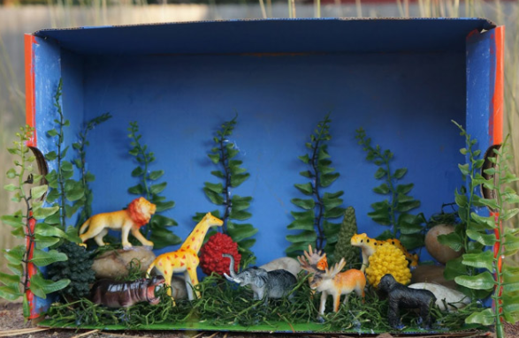  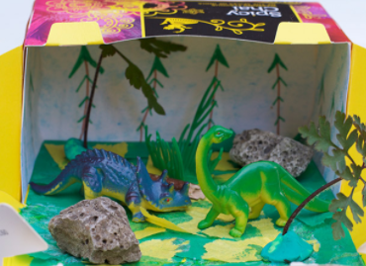  Write sentences to explain why you have included certain features.

